Assignment 1
MSS301 – Cinema Ticket Booking System using API Gateway
Created by: traltb@fe.edu.vn
Link github: https://github.com/hungkizsp/MSS301_FA26_PhanThanhHung/tree/main/Assignment

Mục lục

1. – Hạ tầng: Docker Compose 3 database (F0) 4
1.1. TODO 0.1 Tạo thư mục gốc 4
1.2.TODO0.2mysql/init.sql tạo 3 database cinema_customer, cinema_movie, cinema_booking 4
1.3. – Khởi động & kiểm tra 4
2. F1- Authentication (customer-service + Gateway) 6
2.1. (TODO 0.3) Flyway V1__init.sql (bảng customer) + V2__seed.sql (3 customer mẫu, 1 INACTIVE) 6
2.2. (TODO 0.5, 1.1) – ‘application.properties’ 7
2.3. (TODO 2.1) – Flyway migration 8
2.4. (TODO 0.6) – Xử lý lỗi dùng chung 8
2.5. (TODO 2.2) – Model & Repository 10
2.6. (TODO 2.3, 3.1) – DTO 11
2.7. (TODO 1.2, 1.3) – PasswordEncoder & JwtService 14
2.8. (TODO 1.4) – `service/AuthService.java` 15
2.9. (TODO 2.4, 2.5, 3.2) – `service/CustomerService.java` 16
2.10. (TODO 1.5, 2.6, 3.3) – Controller 19
2.11. Chạy & kiểm tra nhanh customer-service 20
3. movie-service với MongoDB 21
3.1. (TODO 0.3) – Generate project 21
3.2. (TODO 0.5) – `application.properties` 22
3.3. (TODO 4.2, 5.1, 6.1) – Enum 23
3.4. (TODO 4.2, 5.1, 6.1) – Document 24
3.5. (TODO 4.2, 5.2, 6.2) – Repository 27
3.6. – DTO (ID là `String`) 28
3.7. (TODO 4.3) – `GenreService` & `RoomService` 31
3.8. (TODO 5.2, 5.3) – `service/MovieService.java` 32
3.9. (TODO 6.3, 6.4) – `service/ShowtimeService.java` 32
3.10. (TODO 4.1) – `config/DataSeeder.java` 34
3.11. (TODO 4.4, 5.4, 6.5) – Controller (`@PathVariable String id`) 35
3.12. – Chạy & kiểm tra movie-service 37
4. Bước 4 – booking-service với MySQL (F7, F8, F9) 38
4.1. (TODO 0.3, 7.1) – Generate project & `pom.xml` 38
4.2. – `application.properties` & main class 39
4.3. (TODO 7.2) – Flyway `V1__init.sql` 39
4.4. (TODO 7.3) – Model 40
4.5. (TODO 9.1) – Repository 41
4.6. (TODO 7.4) – OpenFeign client 41
4.7. – DTO request/response 42
4.8. (TODO 7.5, 7.6, 8.1–8.3, 9.2) – `service/BookingService.java` 43
4.9. (TODO 7.7, 8.4, 9.3) – `controller/BookingController.java` 45
4.10. Chạy booking-service 46
5. api-gateway (F10) 47
5.1. (TODO 0.4) – Generate project & `pom.xml` 47
5.2. (TODO 10.1) – `application.properties` 47
5.3. (TODO 10.2) – `filter/UserHeaderFilter.java` 48
5.4. (TODO 10.3) – `routes/Routes.java` 49
5.5. (TODO 10.4) – `config/SecurityConfig.java` 50
5.6. Bước 5.6 – Chạy gateway 50
6. Chạy toàn hệ thống 51
7. Kiểm thử API bằng Postman (F11) 51
7.1. (TODO 11.1) – Tạo Environment 51
7.2. (TODO 11.2) – Tạo Collection & cách cấu hình request 52
7.2.1. Folder 01-Auth (F1) 52
7.2.2. Folder 02-Customer (F2, F3) 55
7.2.3. Folder 03-Genre-Room (F4) 65
7.2.4. Folder 04-Movie (F5) 66
7.2.5. Folder 0-5-Showtime (F6) 66
7.2.6. Folder-06-Booking 68
7.2.7. Folder-07-History-Cancel 70
7.2.8. Folder-08-Report 71
7.2b. - Kiểm tra trực tiếp trong 3 database (sau khi chạy Collection) 71
7.3. (TODO 11.3) – Chạy Collection Runner & nộp bài 72

– Hạ tầng: Docker Compose 3 database (F0)

TODO 0.1 Tạo thư mục gốc
- Chụp hình kết quả: cấu trúc project/ kết quả chạy / output terminal
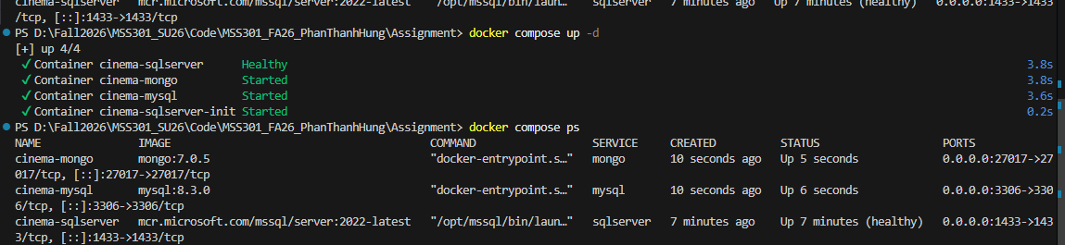

(TODO 0.2) - mysql/init.sql tạo 3 database cinema_customer, cinema_movie, cinema_booking
- Chụp hình kết quả: cấu trúc project/ kết quả chạy / output terminal
- Commit: chore(infra): add docker compose for sql server, mongodb and mysql`
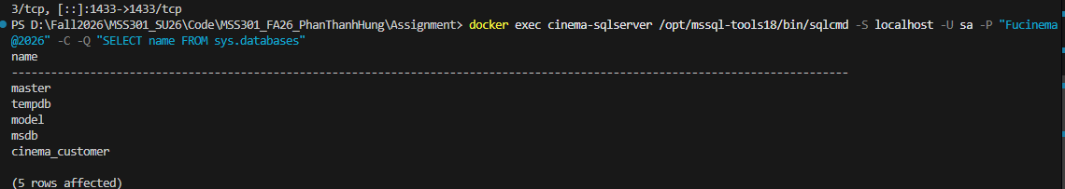

– Khởi động & kiểm tra

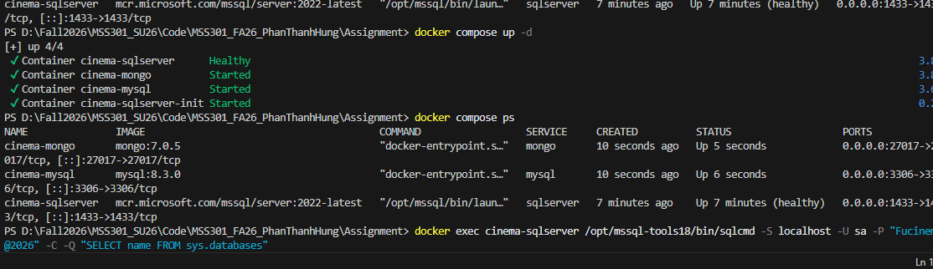

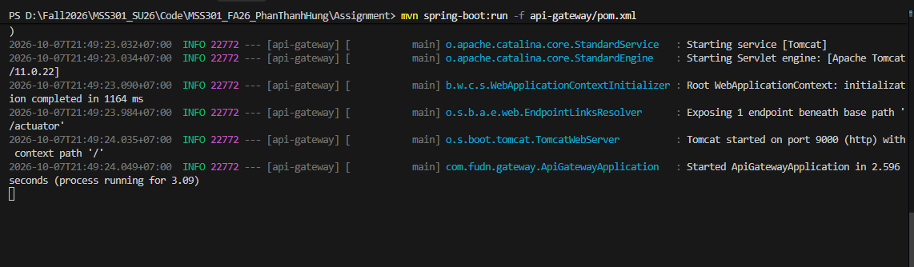

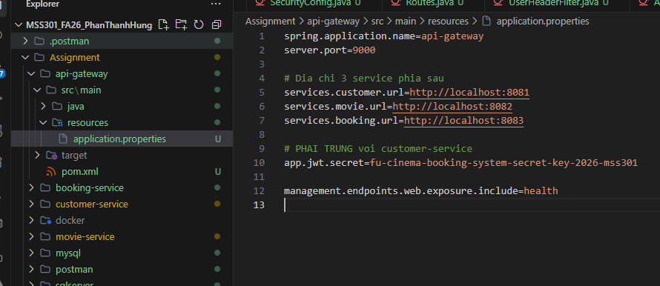

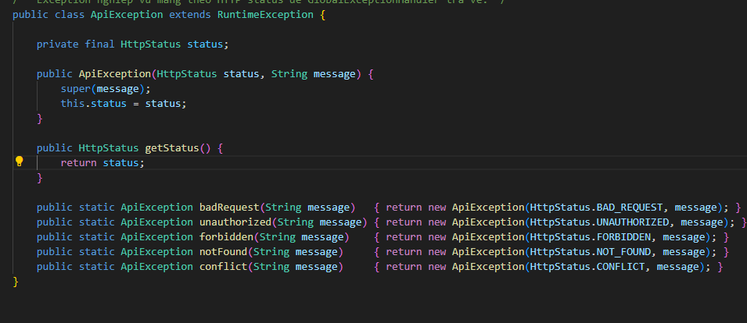
…..
Mỗi mục sẽ gồm kết quả chạy, commit message

F1- Authentication (customer-service + Gateway)

(TODO 0.3) Flyway V1__init.sql (bảng customer) + V2__seed.sql (3 customer mẫu, 1 INACTIVE)
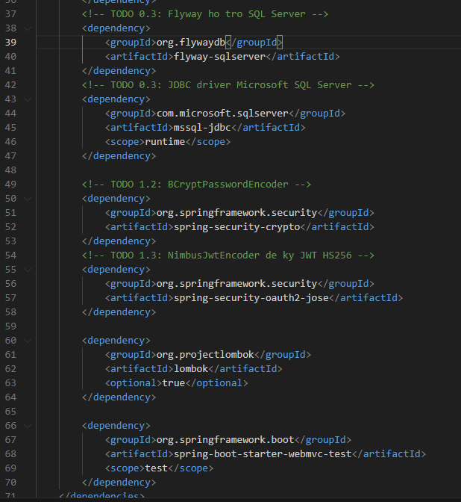

(TODO 0.5, 1.1) – ‘application.properties’
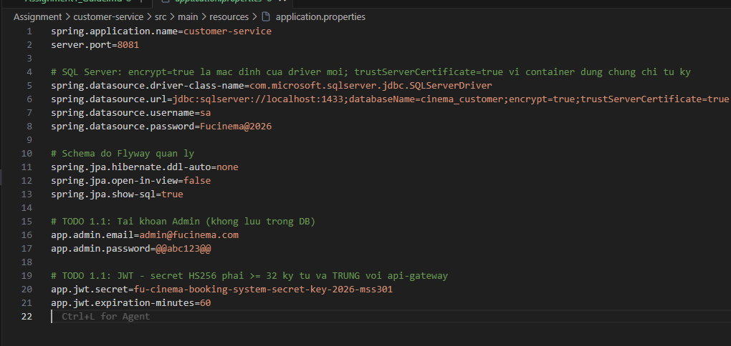

(TODO 2.1) – Flyway migration
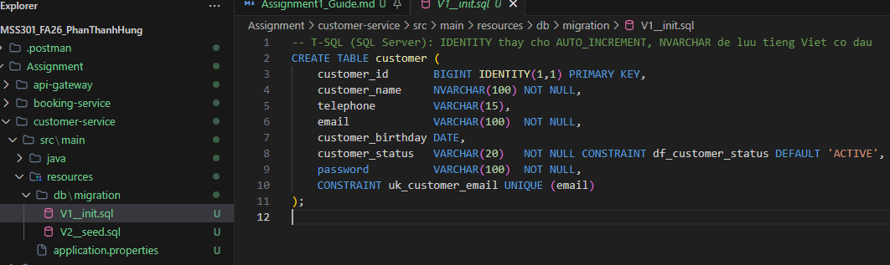

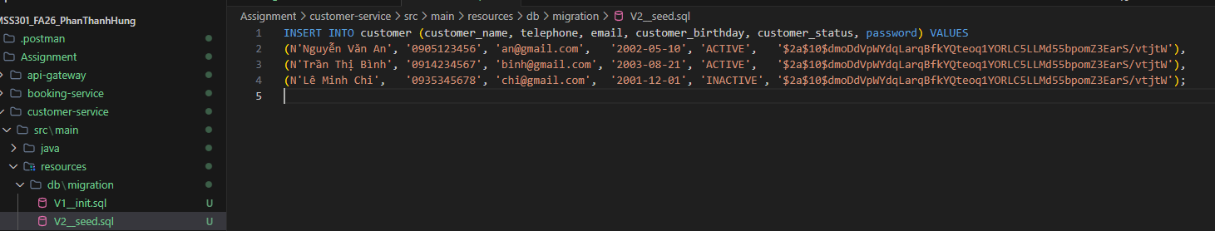

(TODO 0.6) – Xử lý lỗi dùng chung
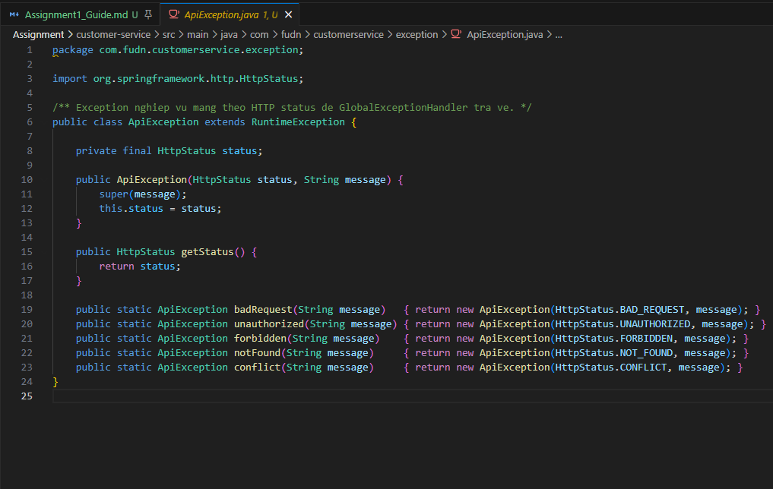

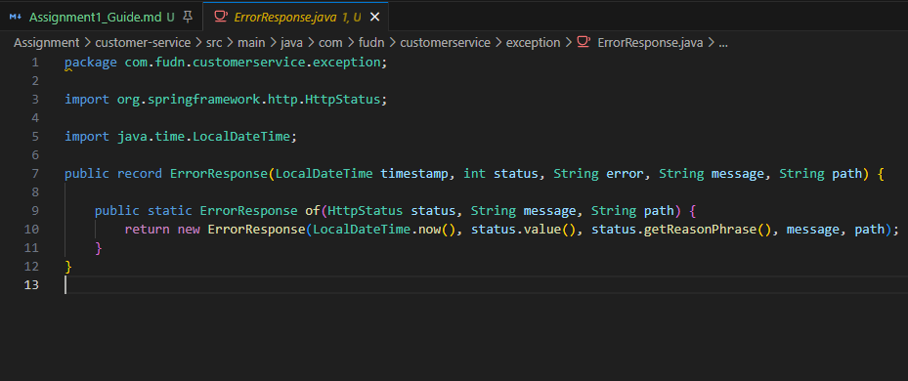

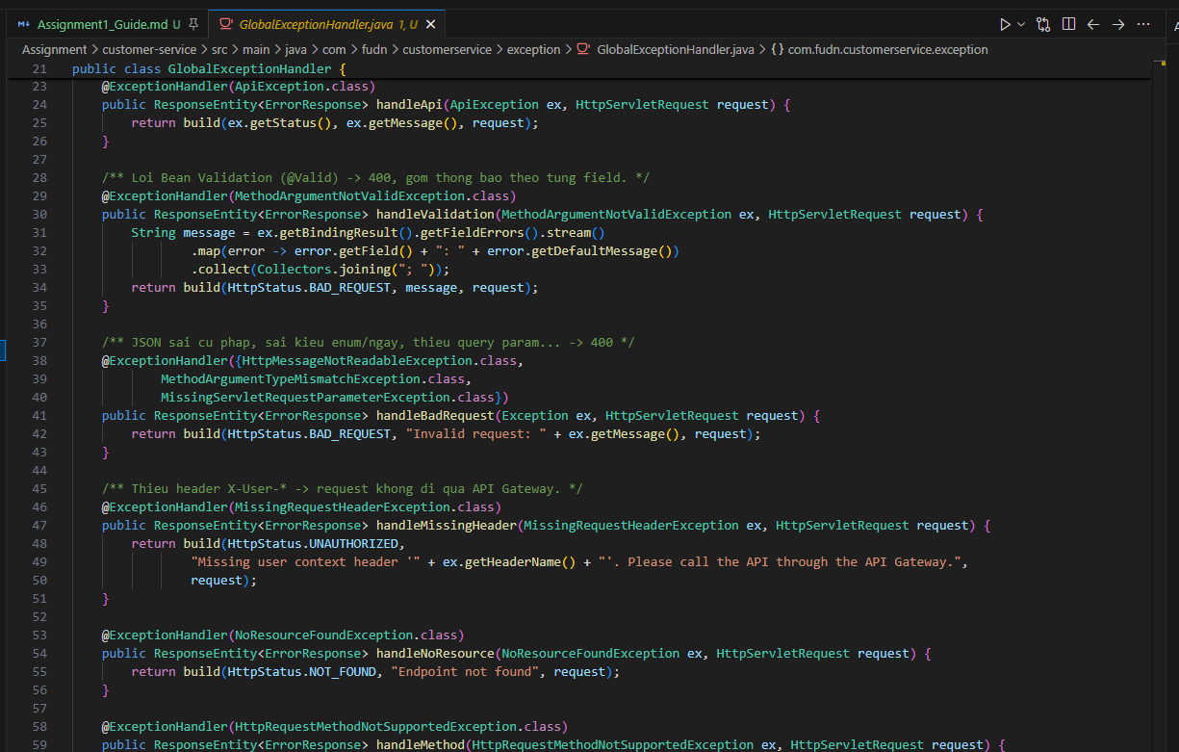

(TODO 2.2) – Model & Repository
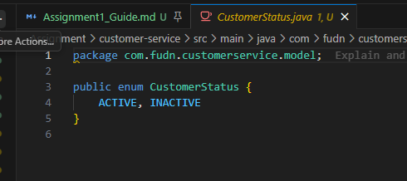
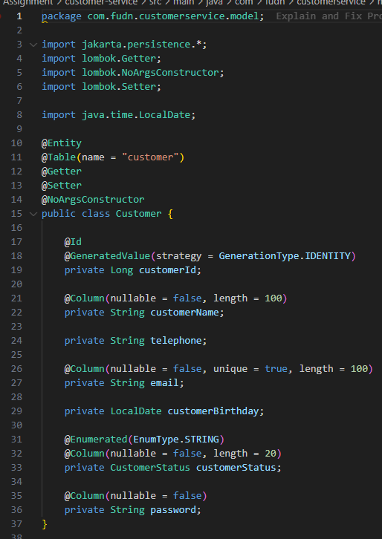

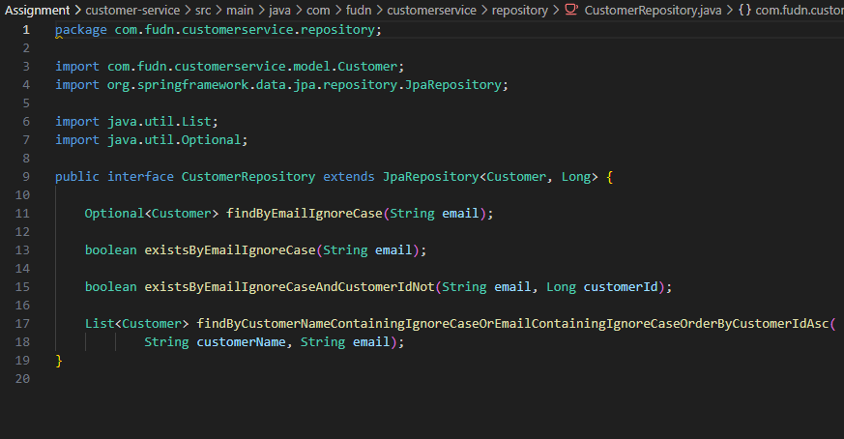

(TODO 2.3, 3.1) – DTO
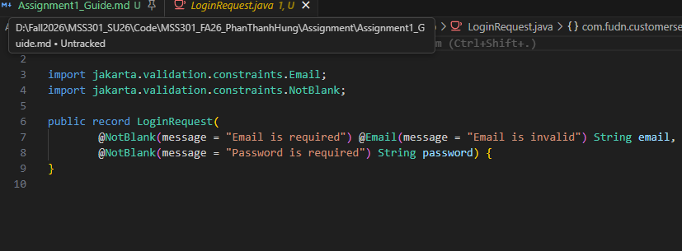

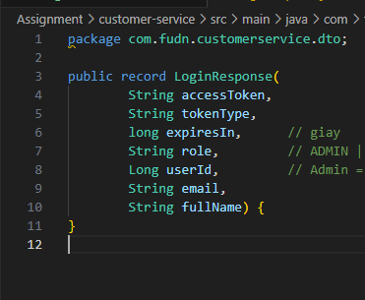

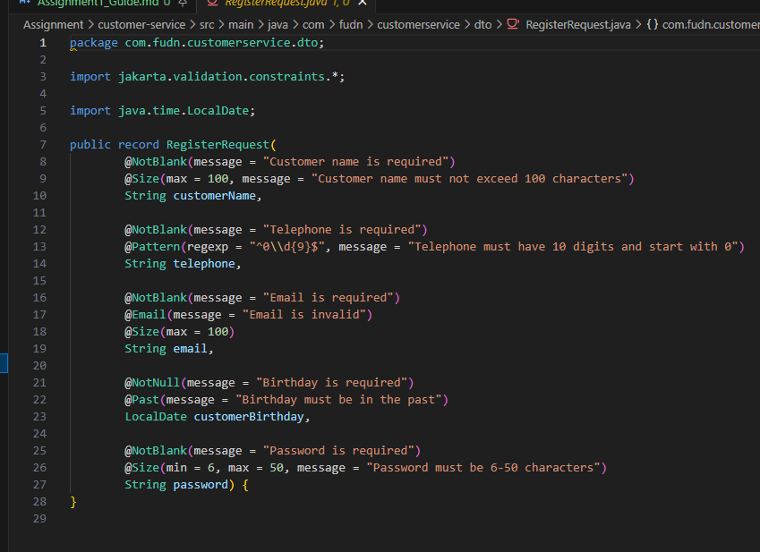

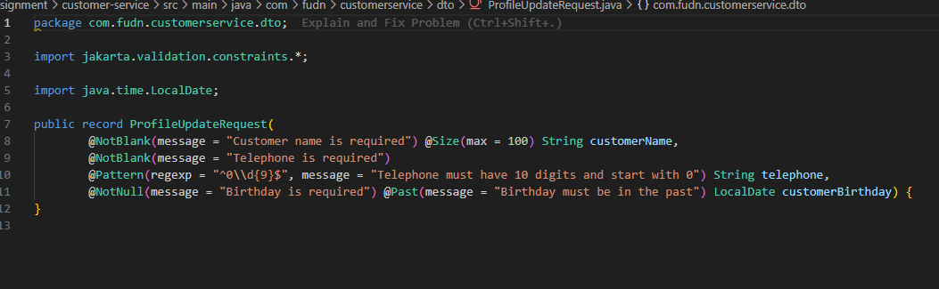

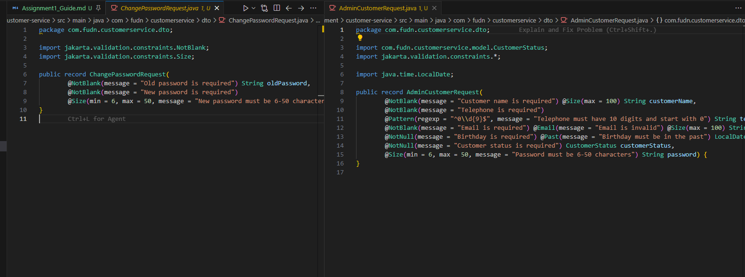

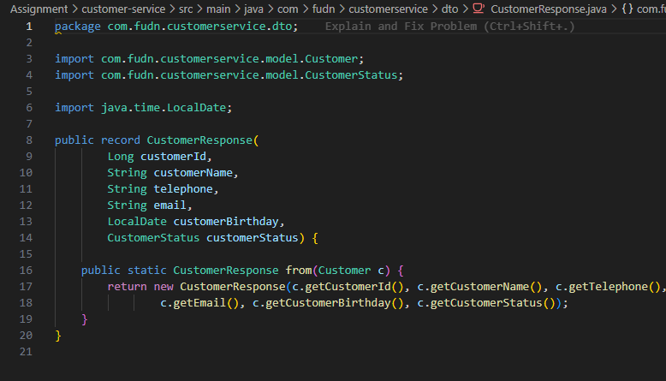

(TODO 1.2, 1.3) – PasswordEncoder & JwtService
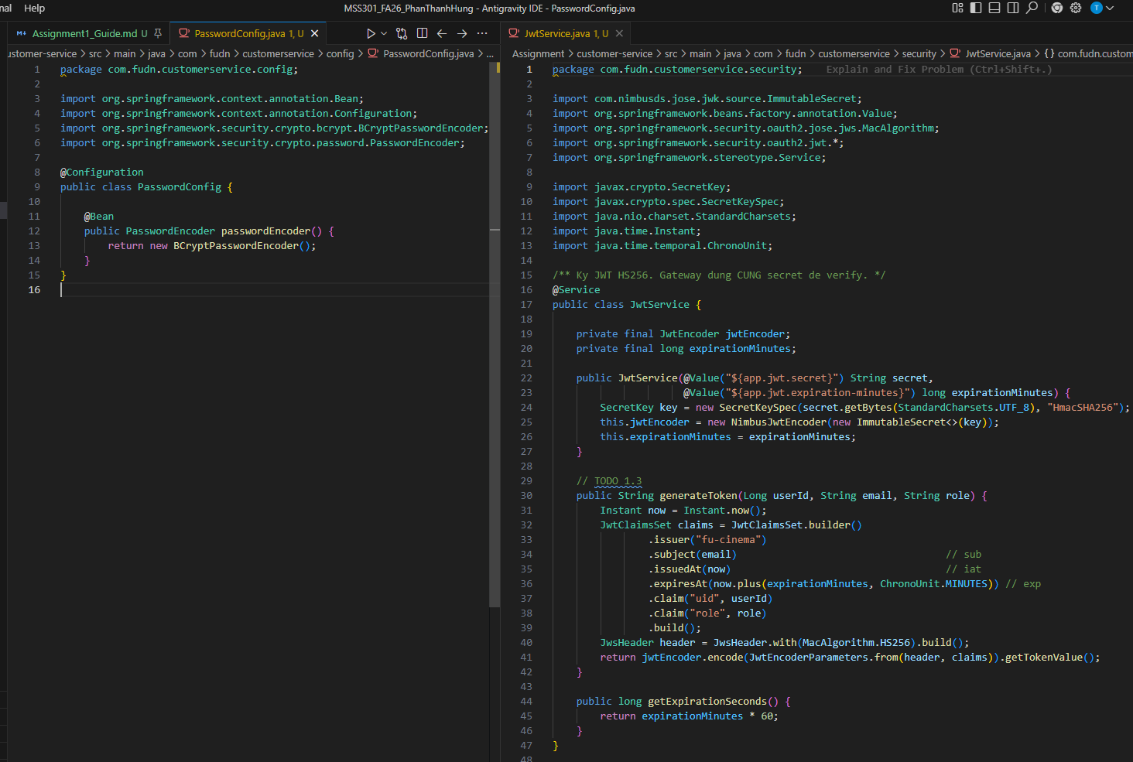

(TODO 1.4) – `service/AuthService.java`
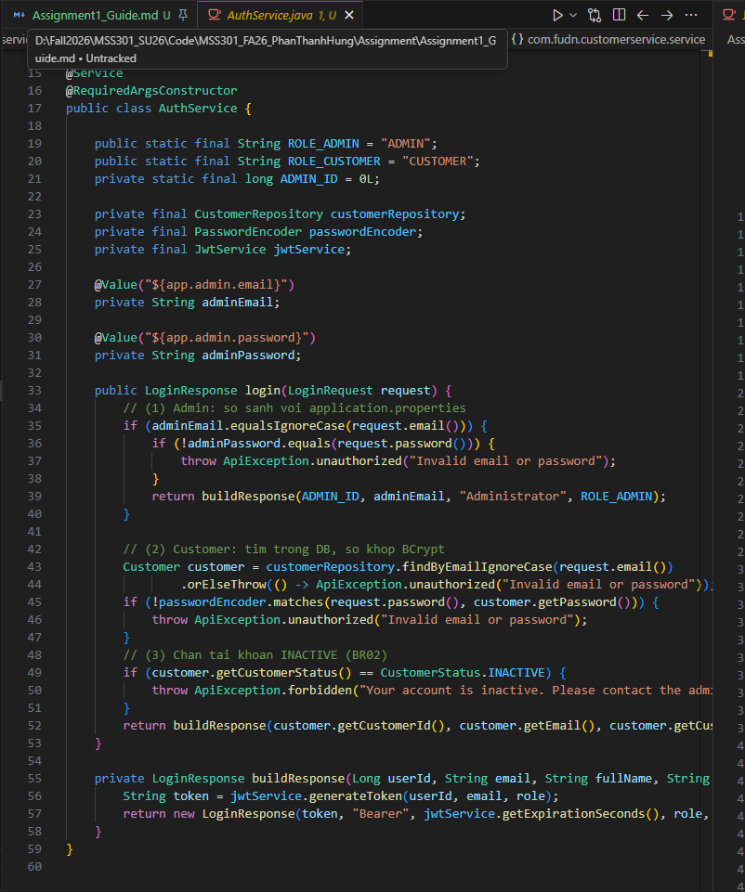

(TODO 2.4, 2.5, 3.2) – `service/CustomerService.java`
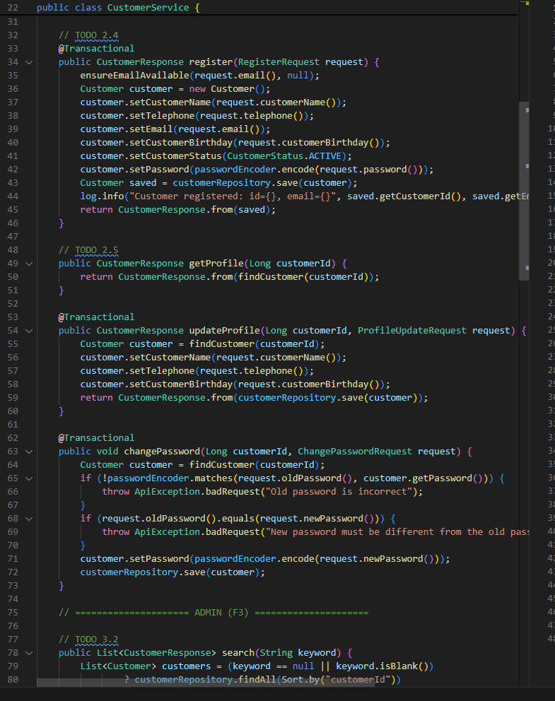

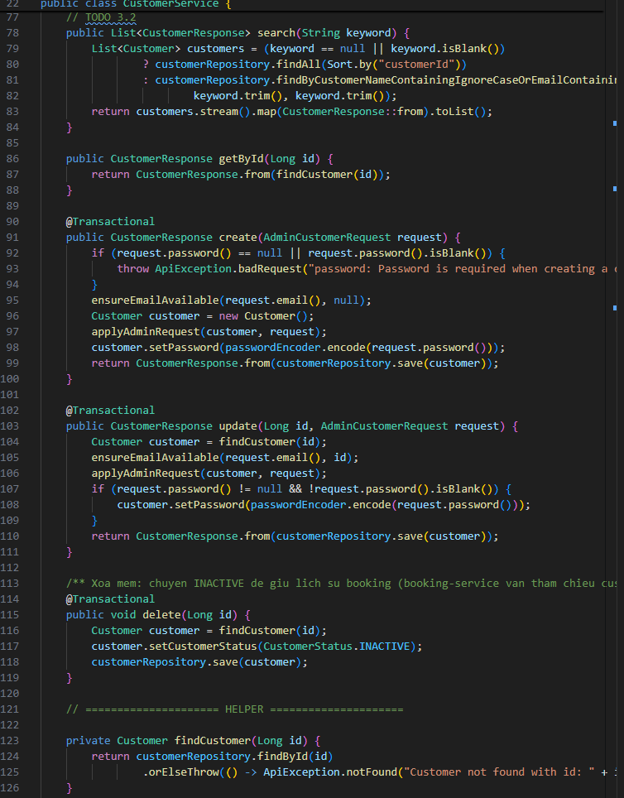
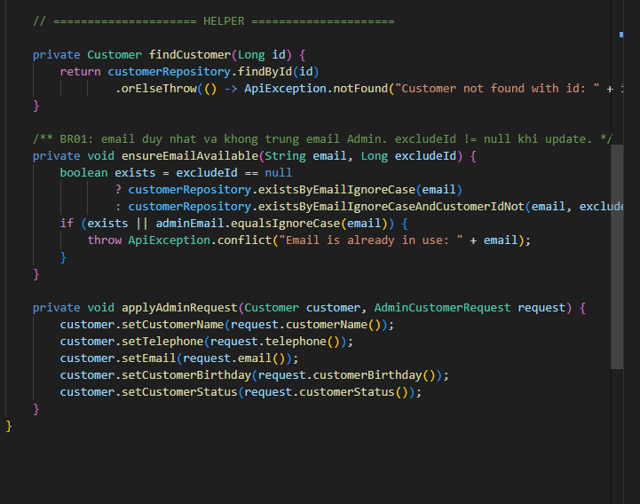

(TODO 1.5, 2.6, 3.3) – Controller
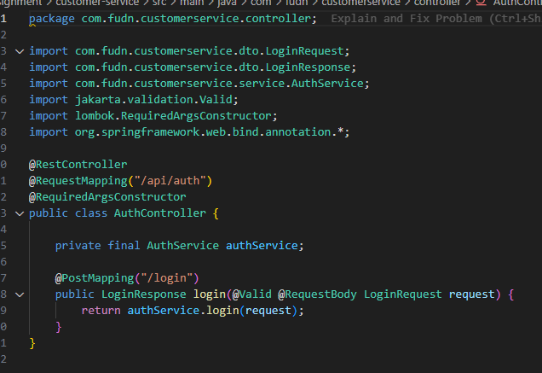

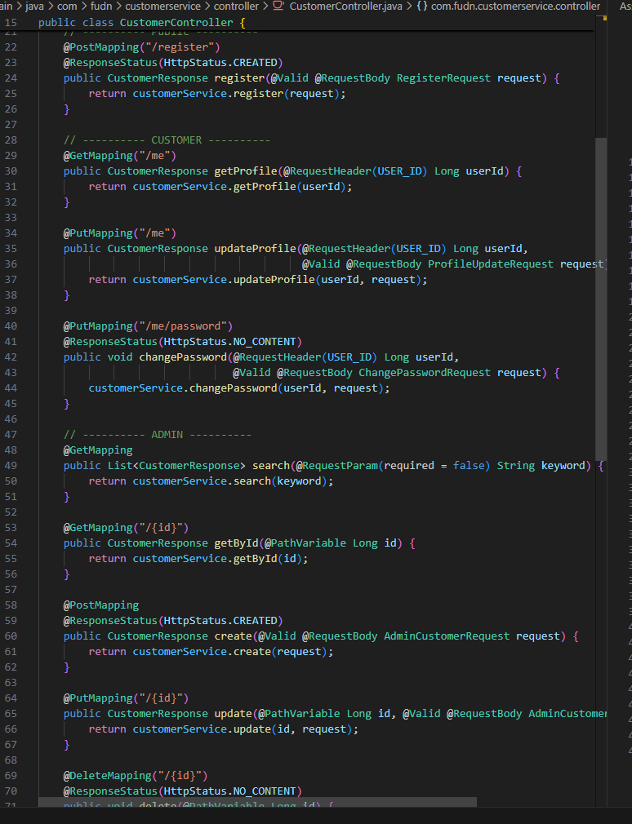

Chạy & kiểm tra nhanh customer-service
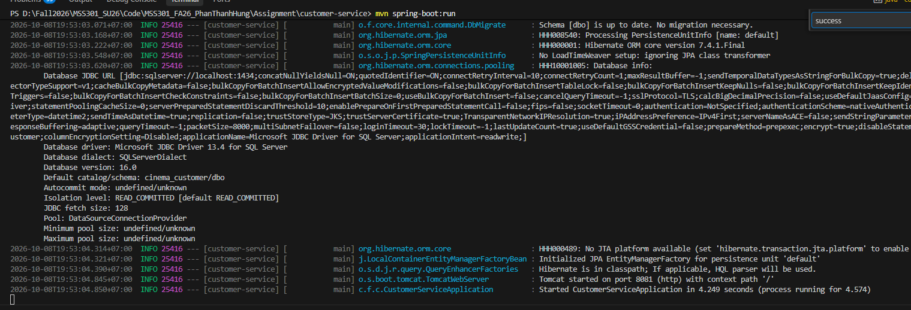
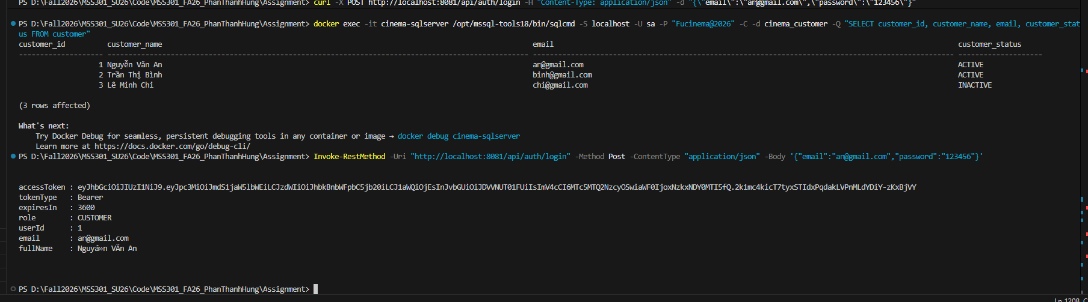

movie-service với MongoDB

(TODO 0.3) – Generate project
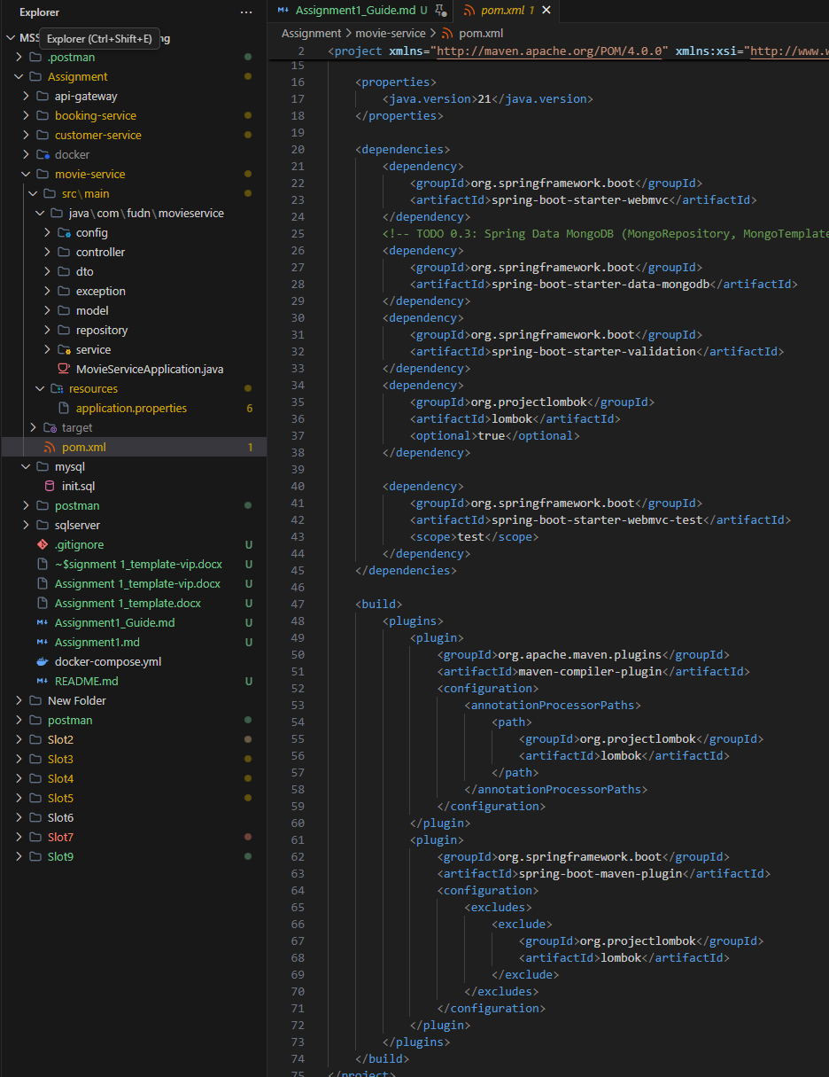

(TODO 0.5) – `application.properties`
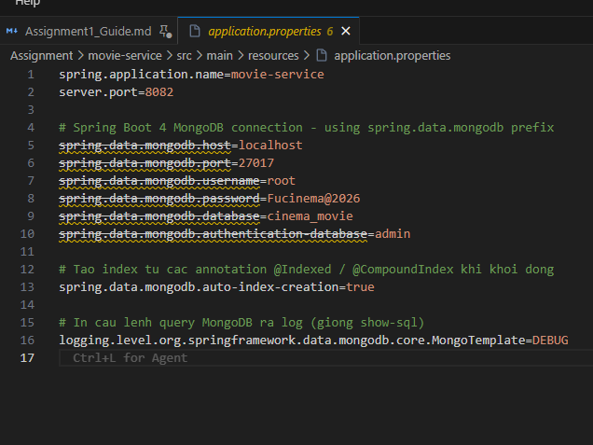

(TODO 4.2, 5.1, 6.1) – Enum
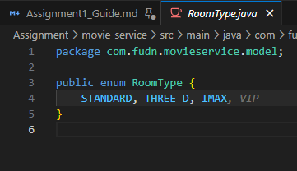
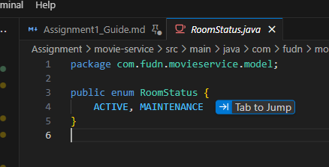
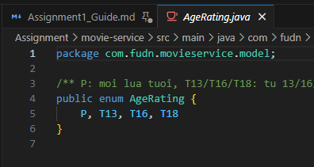
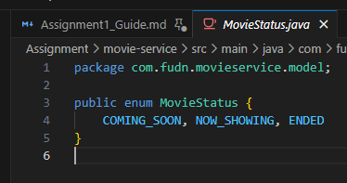
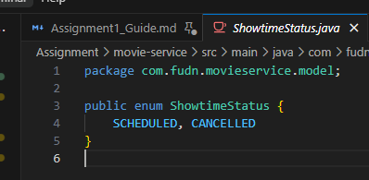

(TODO 4.2, 5.1, 6.1) – Document
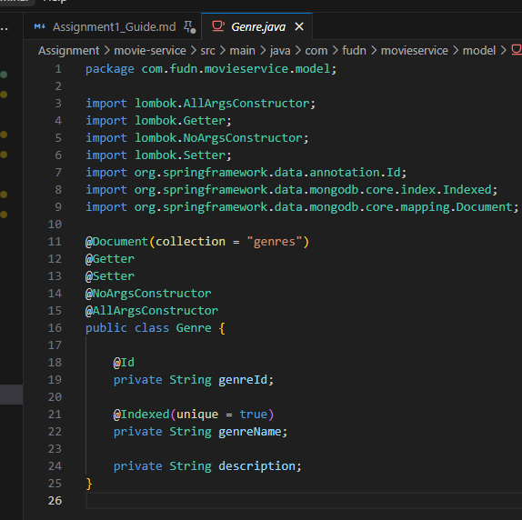
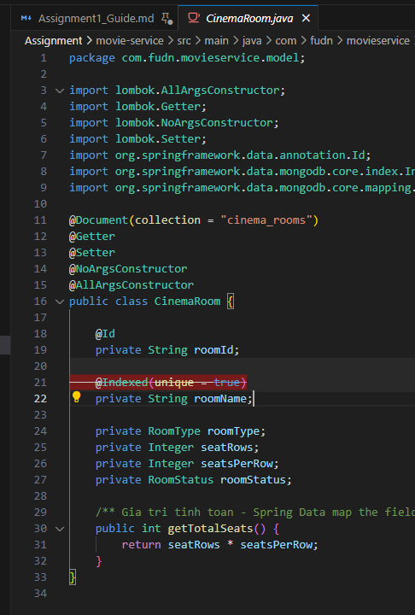
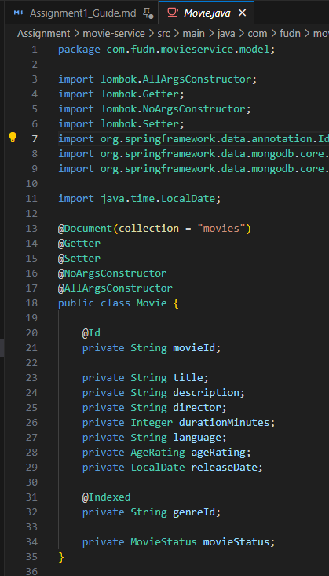
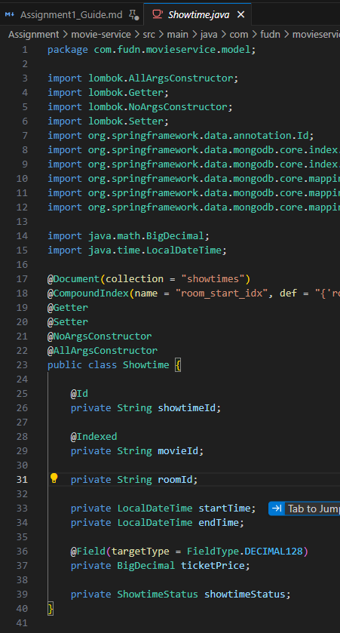

(TODO 4.2, 5.2, 6.2) – Repository
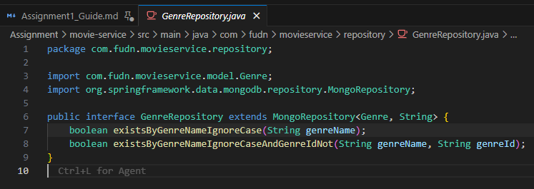
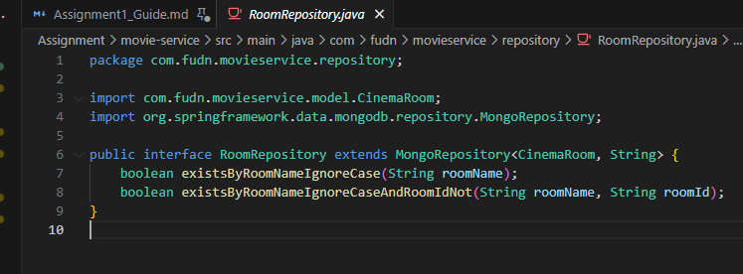
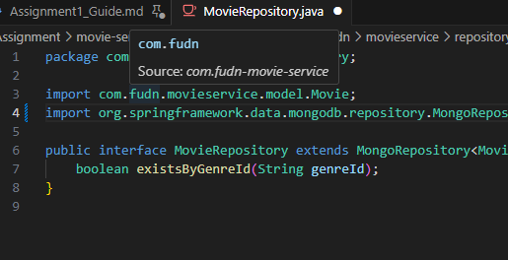

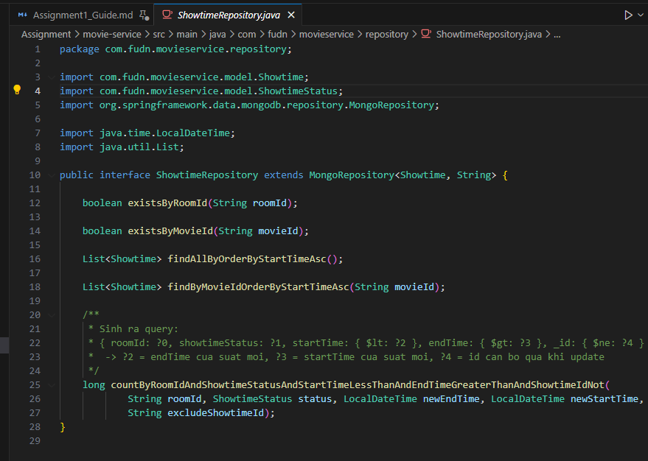

– DTO (ID là `String`)
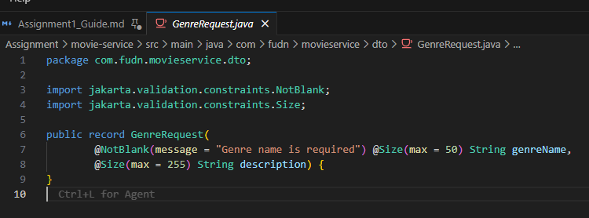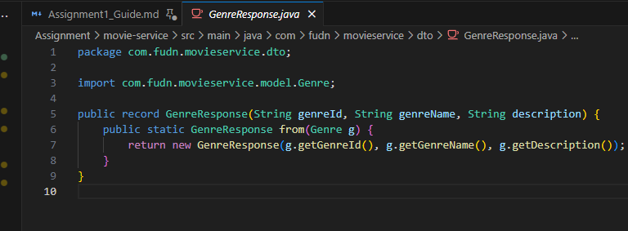
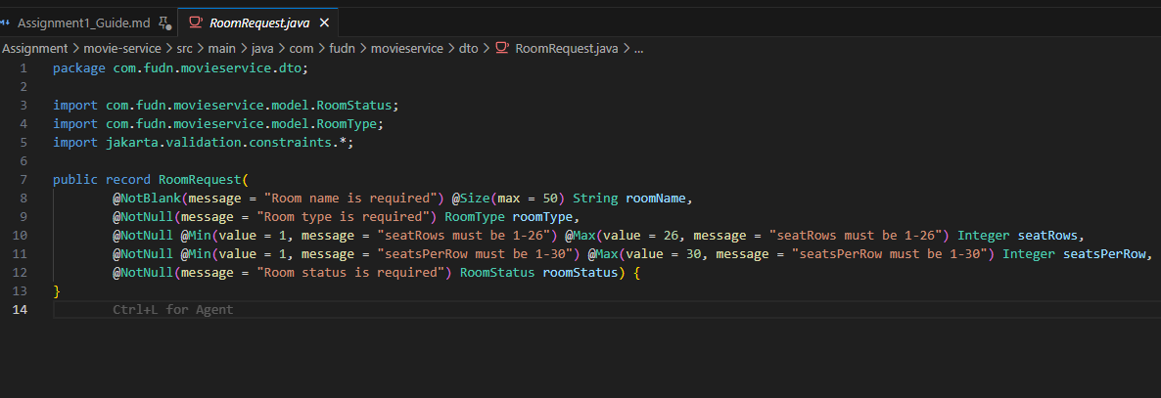
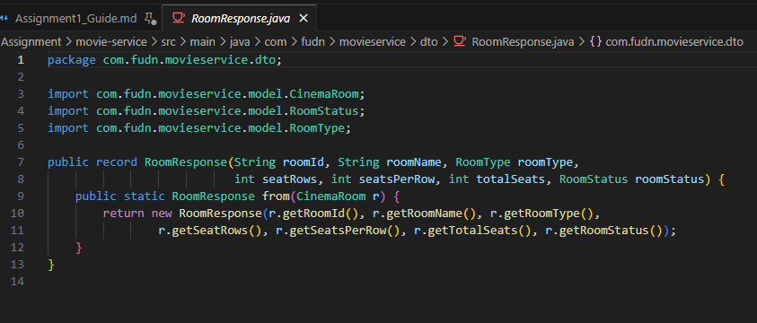
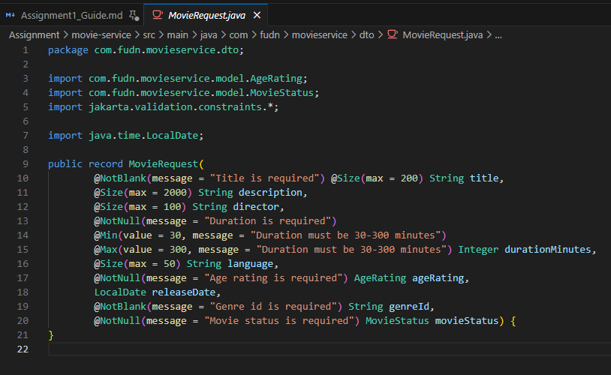
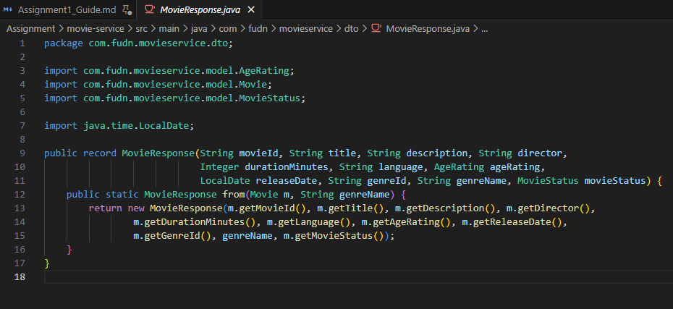
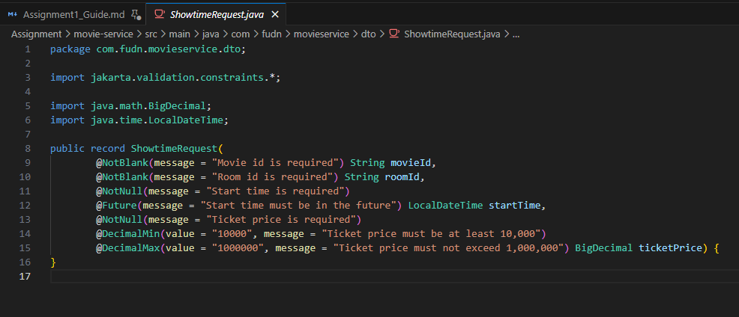
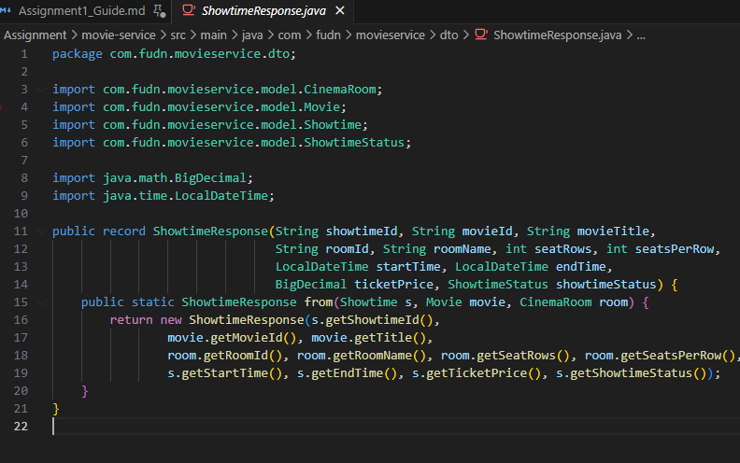

(TODO 4.3) – `GenreService` & `RoomService`
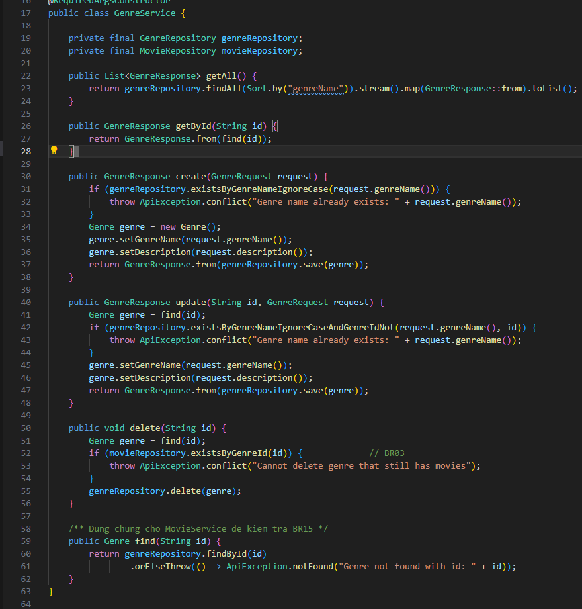
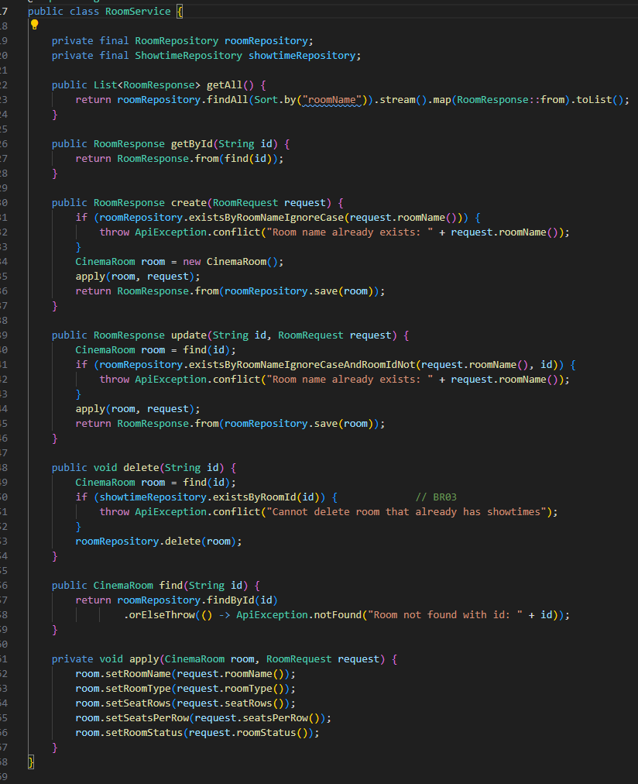

(TODO 5.2, 5.3) – `service/MovieService.java`
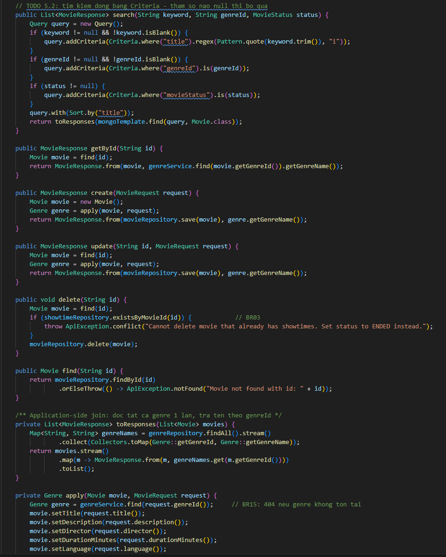

(TODO 6.3, 6.4) – `service/ShowtimeService.java`
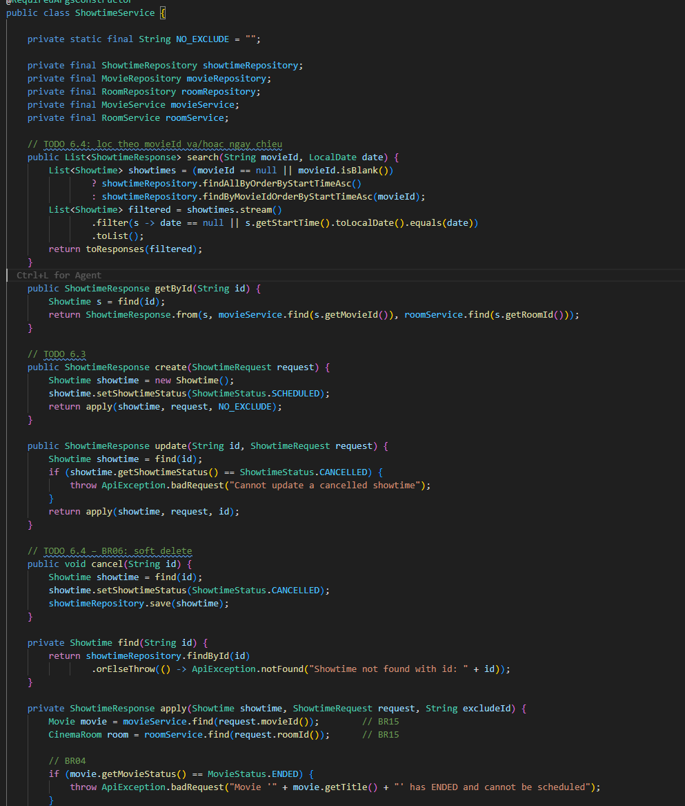
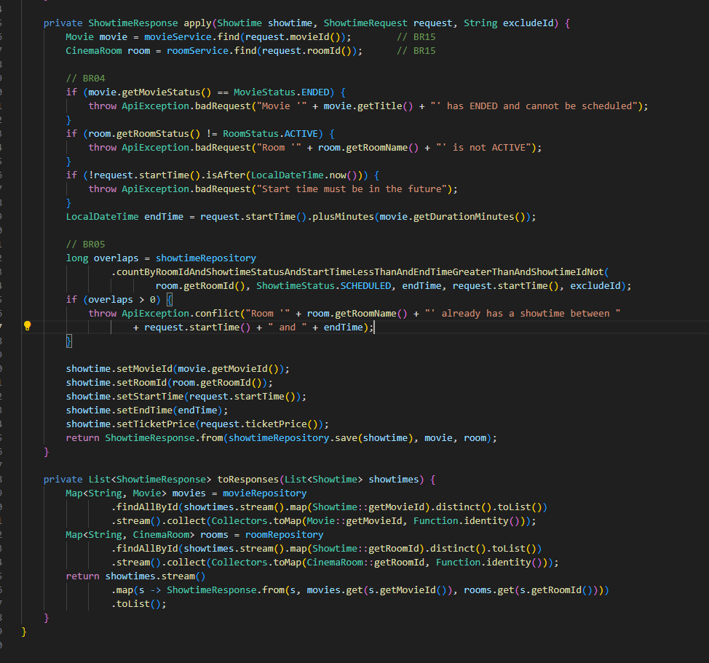

(TODO 4.1) – `config/DataSeeder.java`
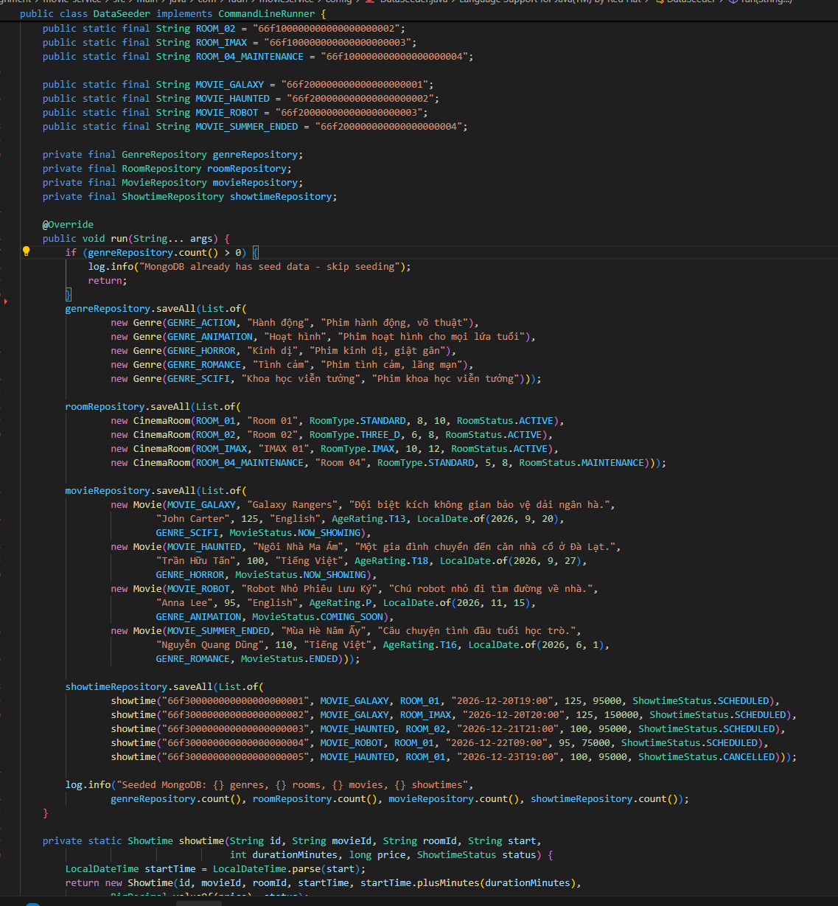

(TODO 4.4, 5.4, 6.5) – Controller (`@PathVariable String id`)
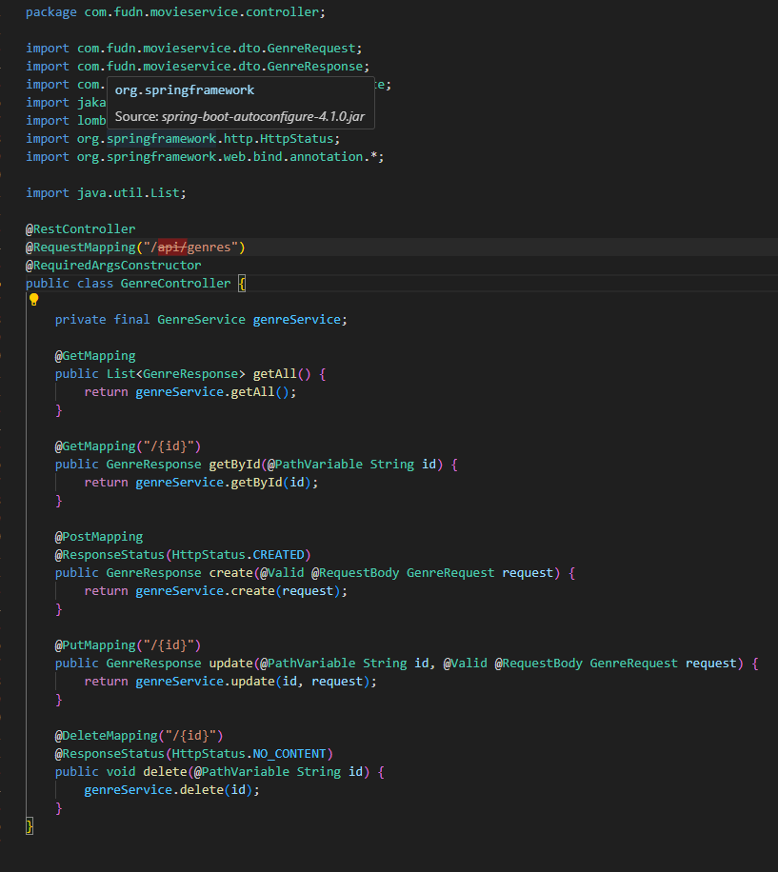
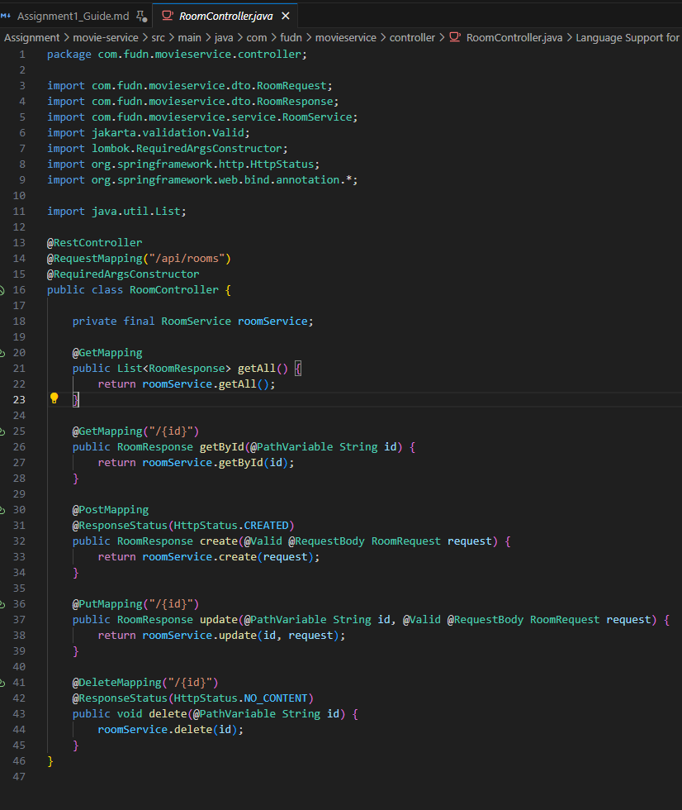
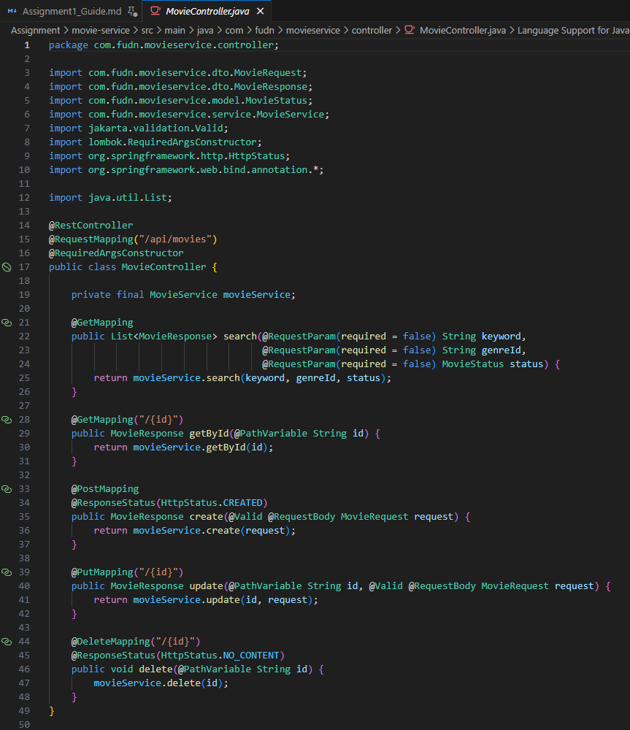
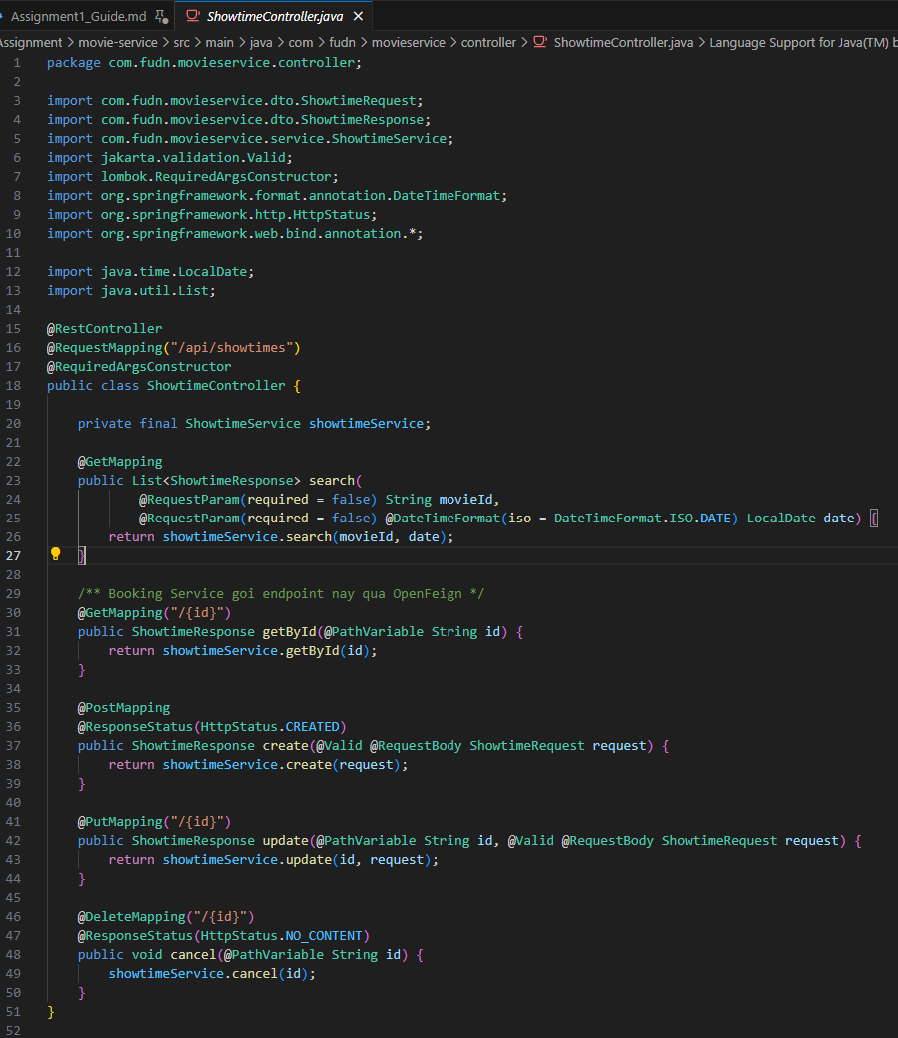

– Chạy & kiểm tra movie-service

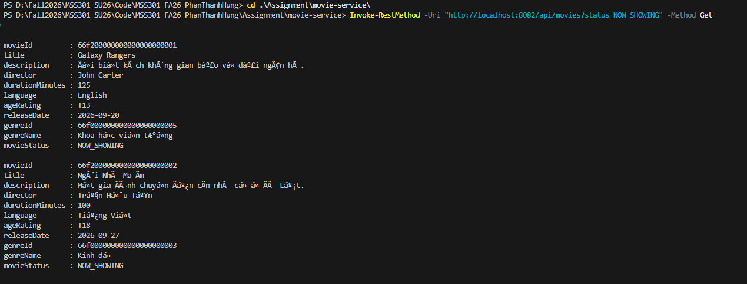
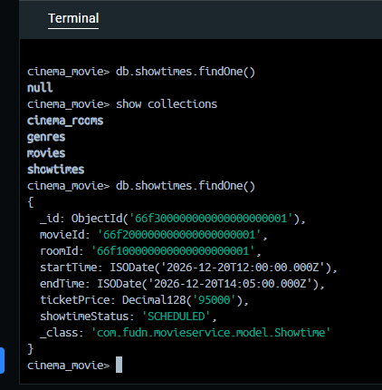

Bước 4 – booking-service với MySQL (F7, F8, F9)

(TODO 0.3, 7.1) – Generate project & `pom.xml`
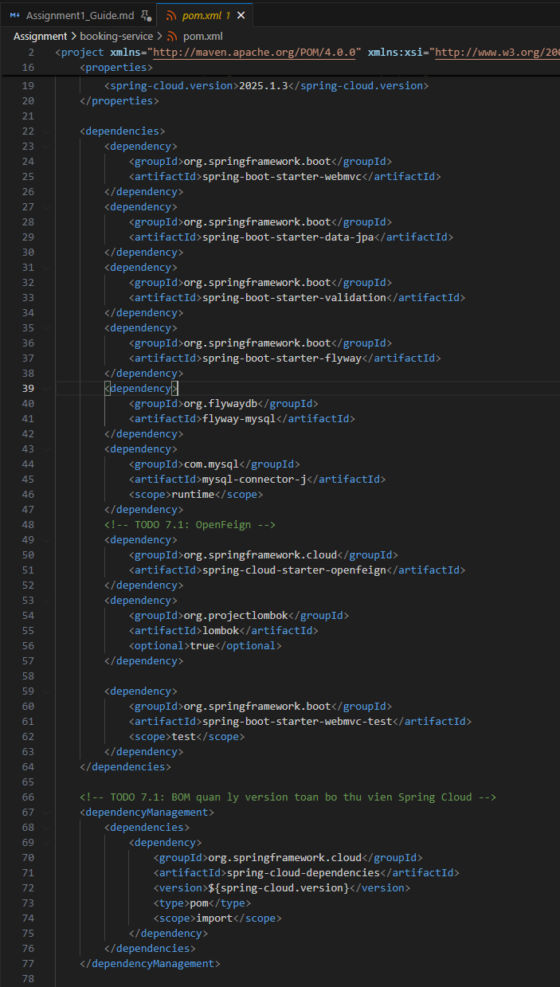

– `application.properties` & main class
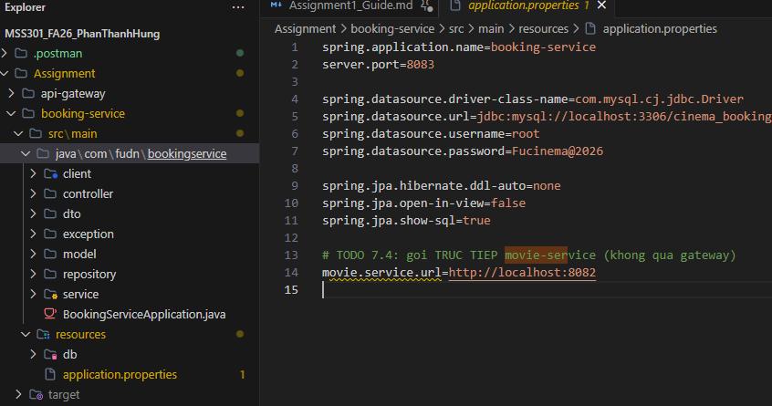

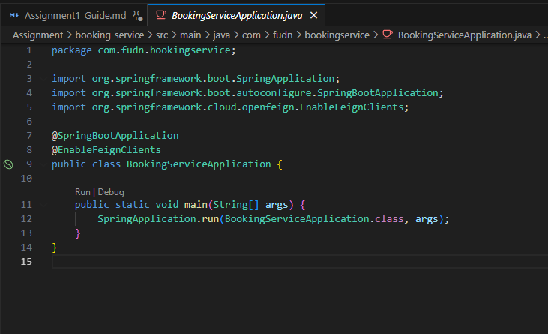

(TODO 7.2) – Flyway `V1__init.sql`
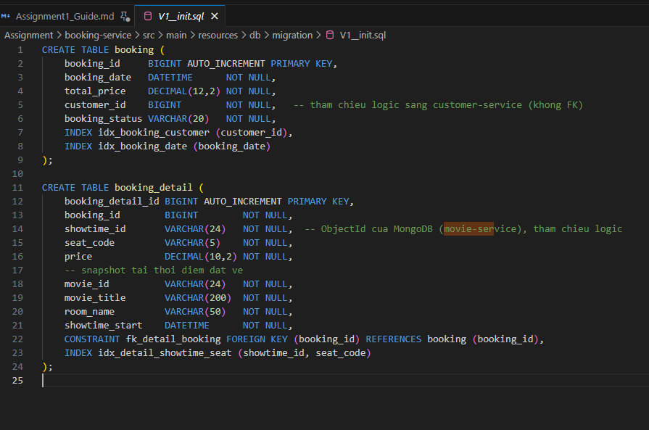

(TODO 7.3) – Model
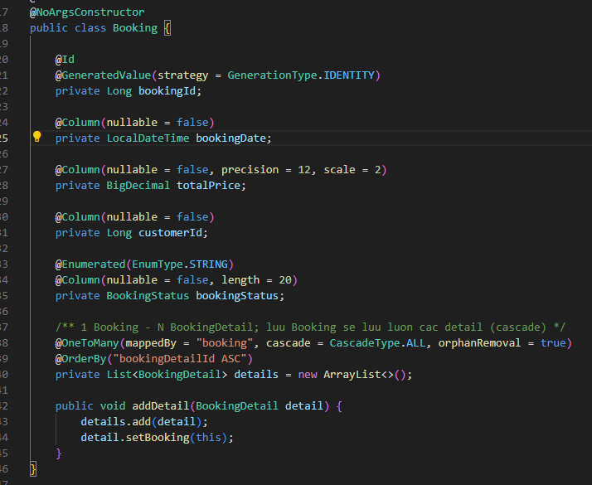
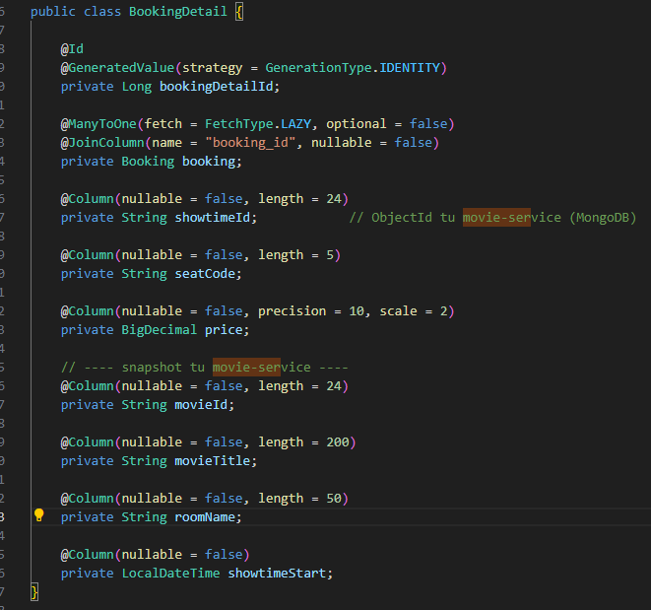
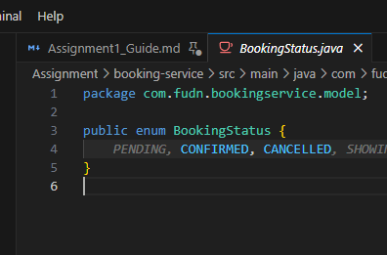

(TODO 9.1) – Repository
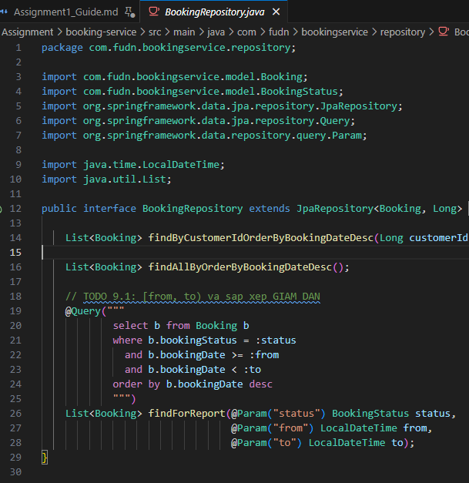
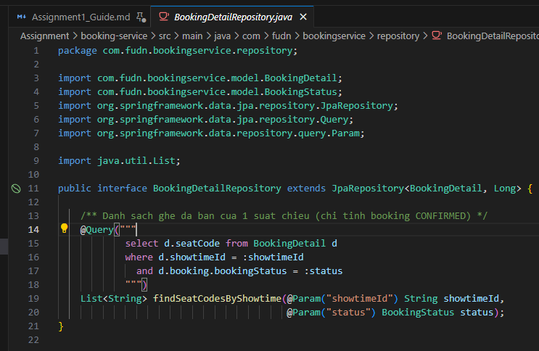

(TODO 7.4) – OpenFeign client
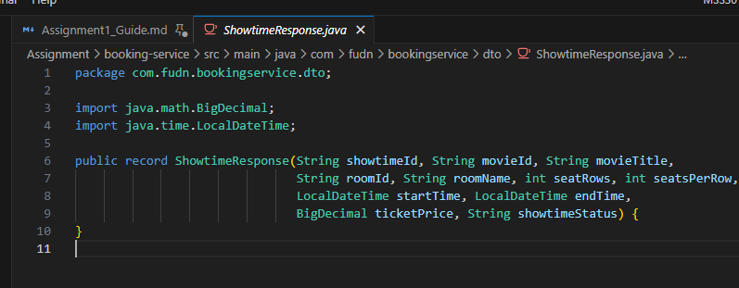
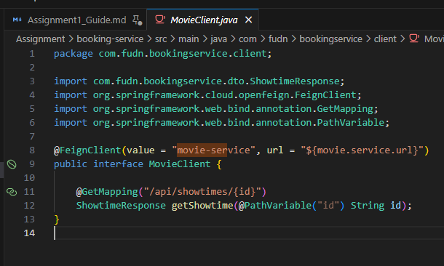

– DTO request/response
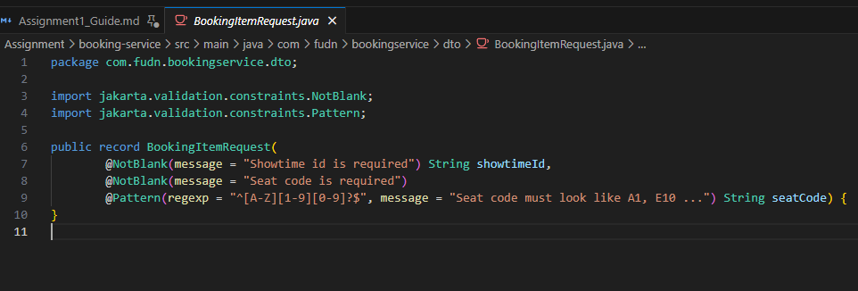
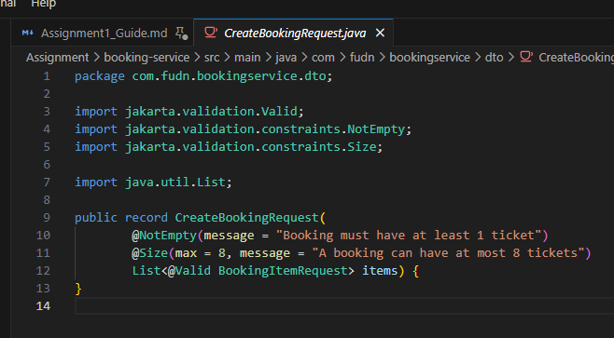
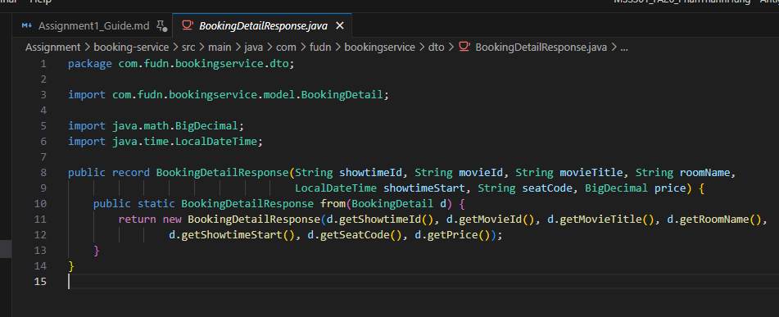
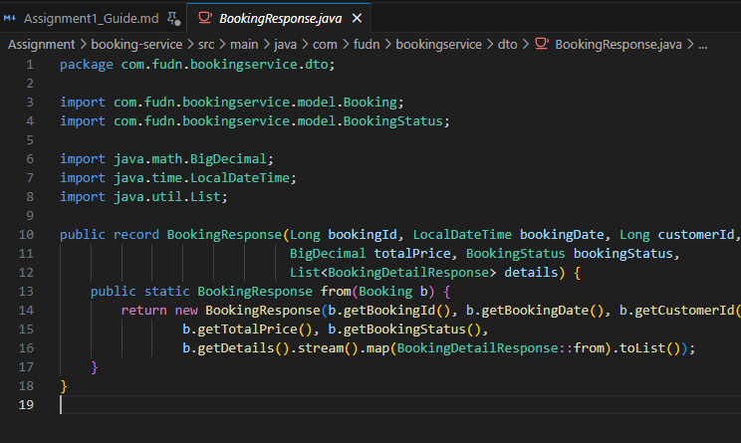
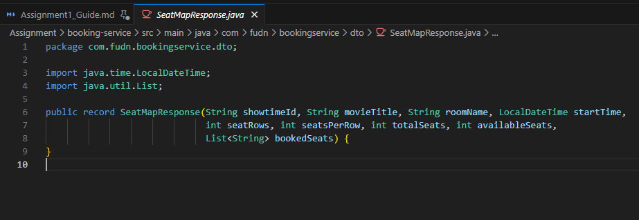
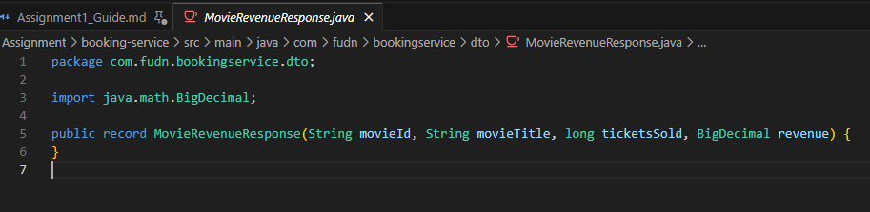
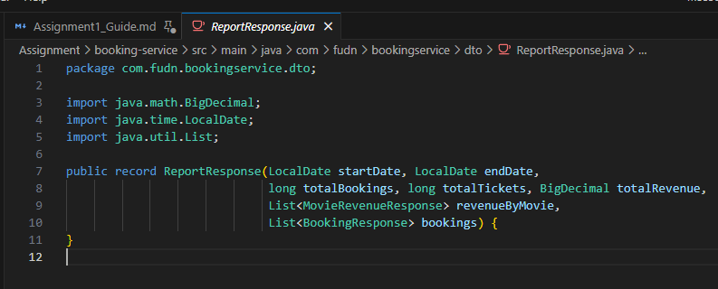

(TODO 7.5, 7.6, 8.1–8.3, 9.2) – `service/BookingService.java`
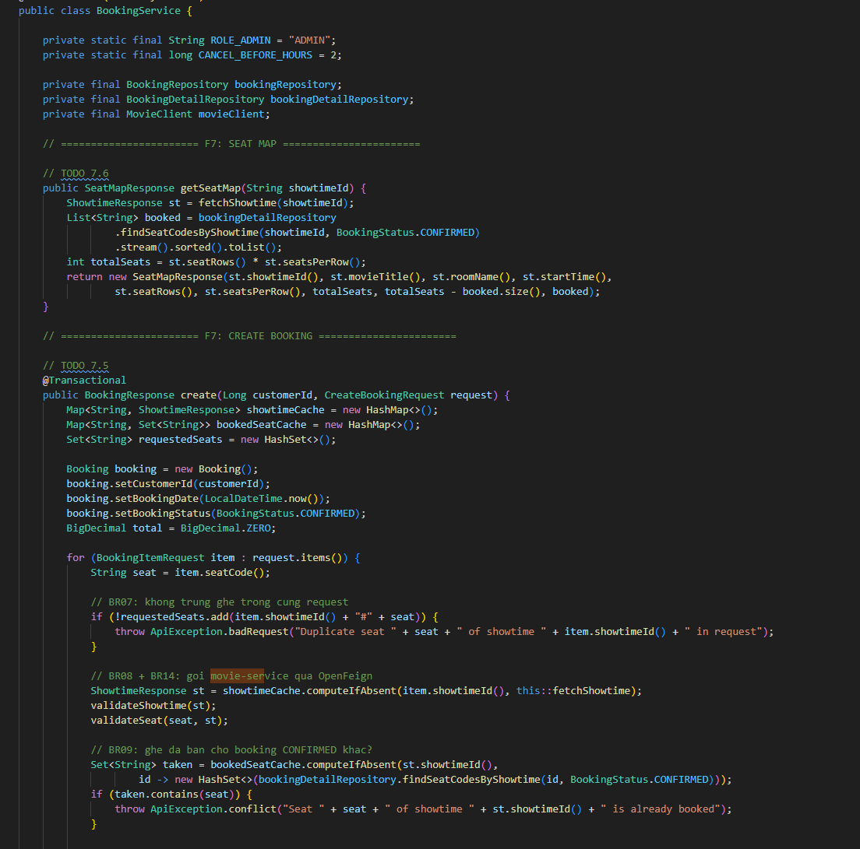
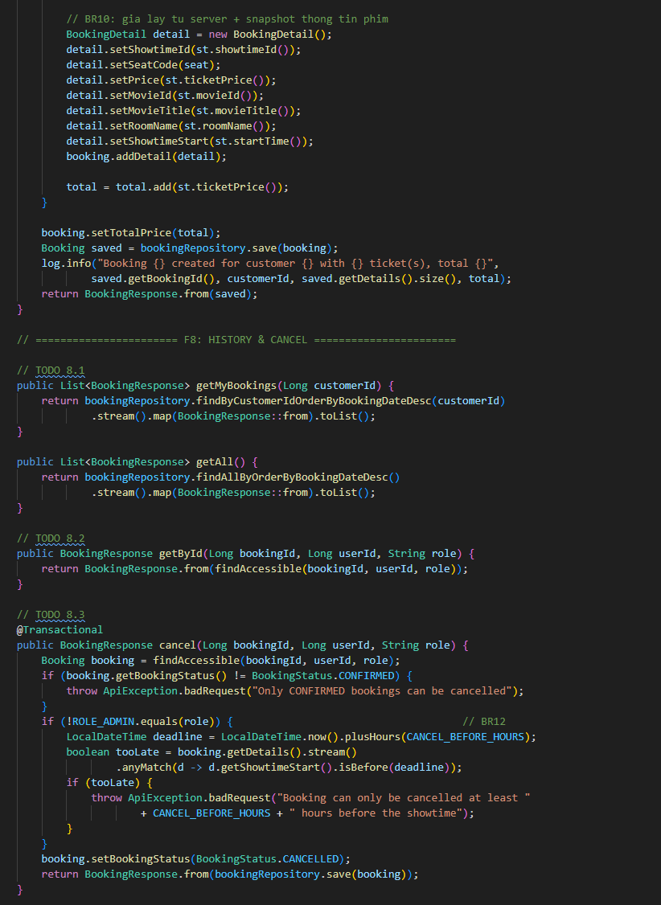

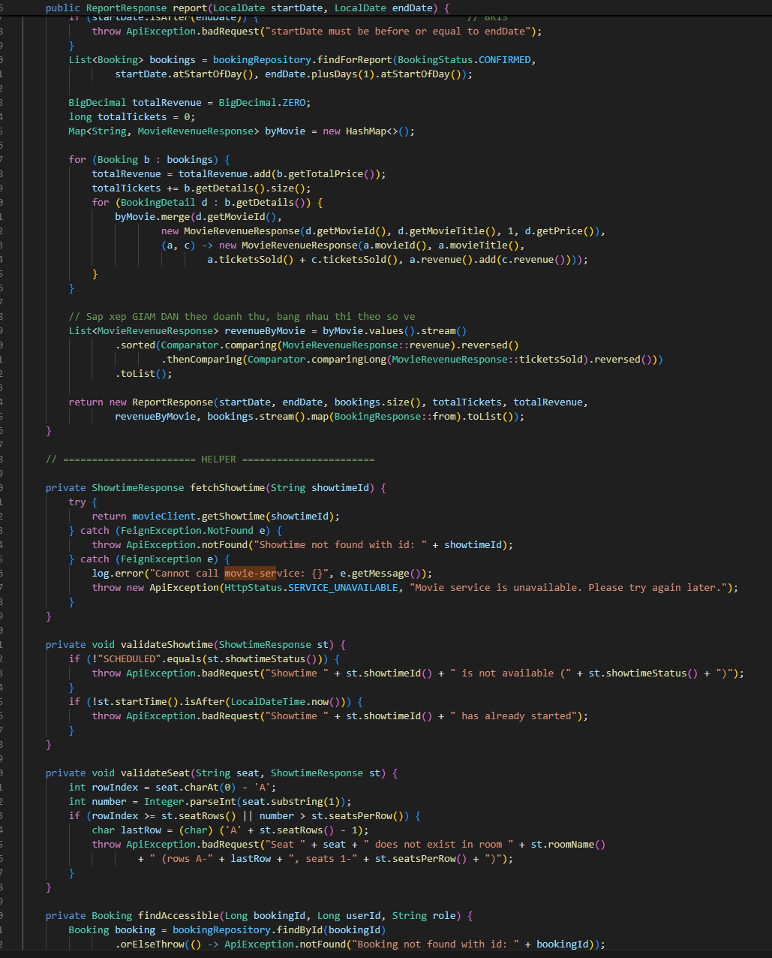

(TODO 7.7, 8.4, 9.3) – `controller/BookingController.java`
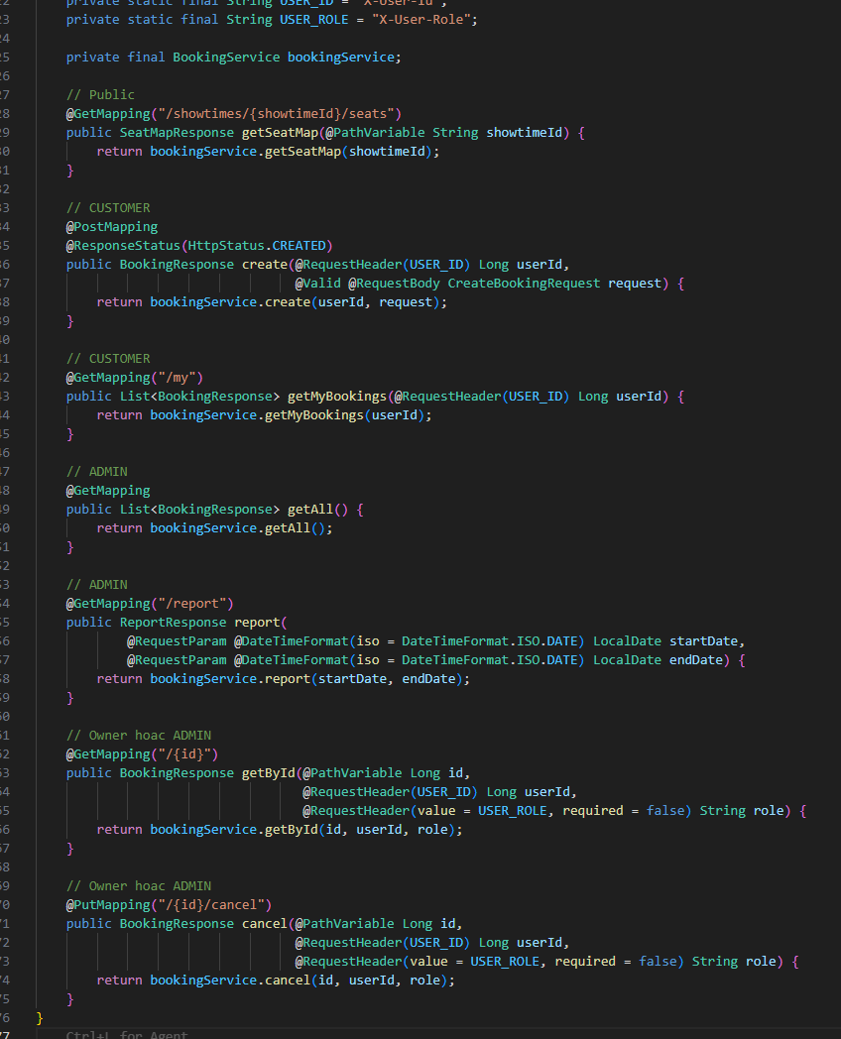

Chạy booking-service
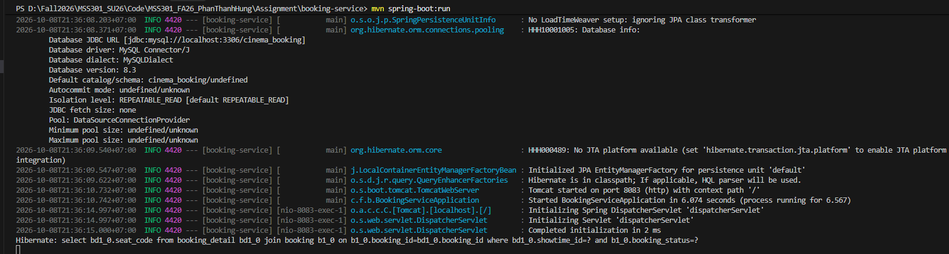
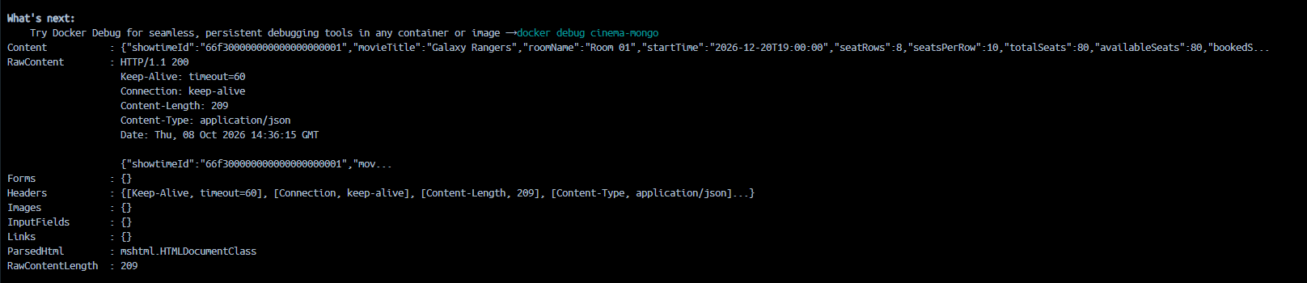

api-gateway (F10)

(TODO 0.4) – Generate project & `pom.xml`
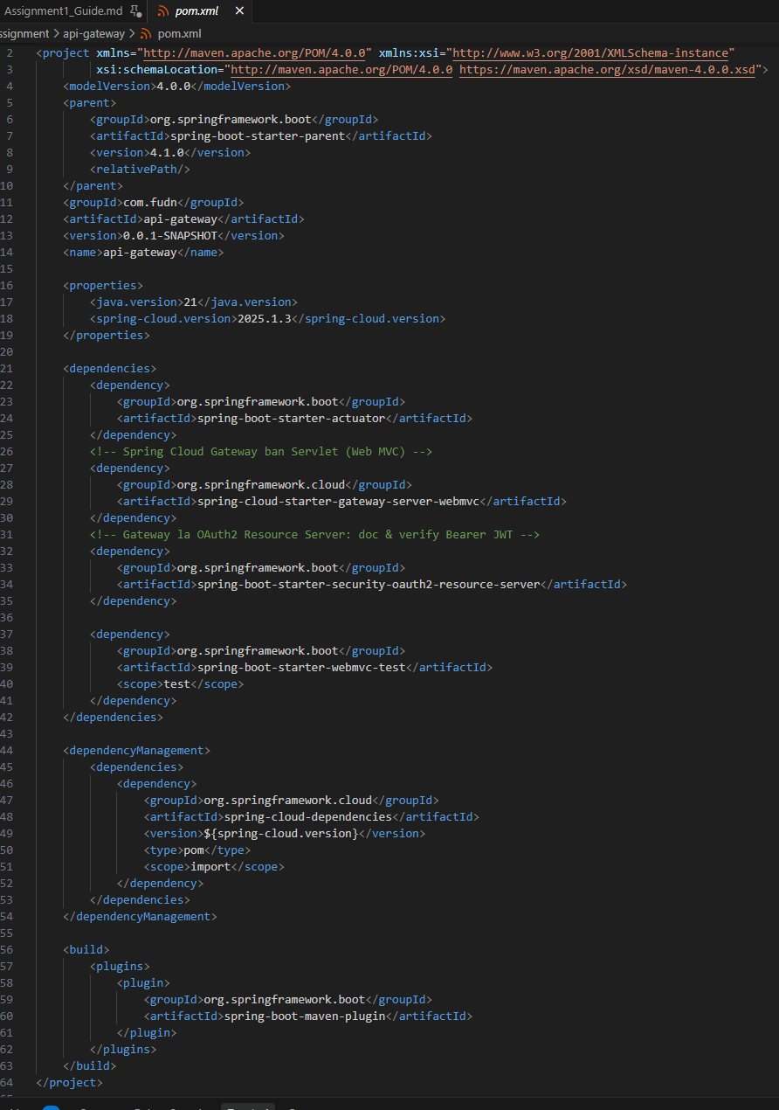

(TODO 10.1) – `application.properties`
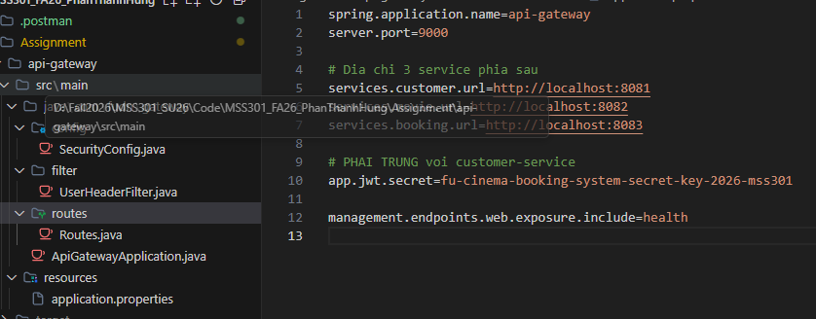

(TODO 10.2) – `filter/UserHeaderFilter.java`
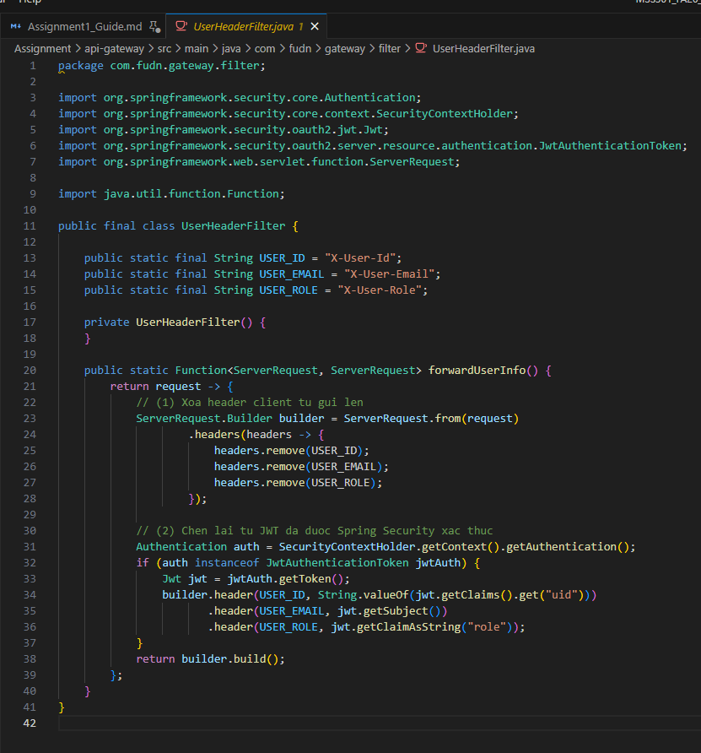

(TODO 10.3) – `routes/Routes.java`
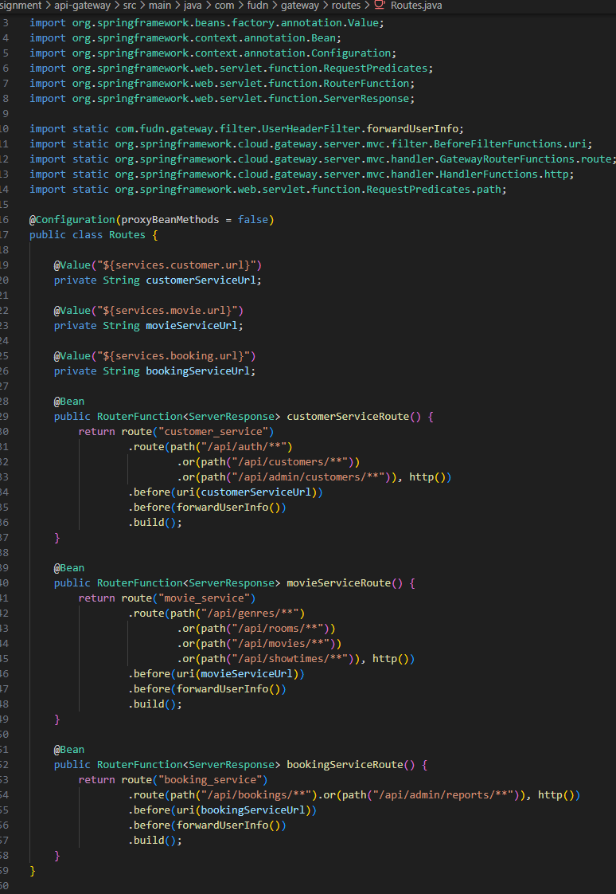

(TODO 10.4) – `config/SecurityConfig.java`
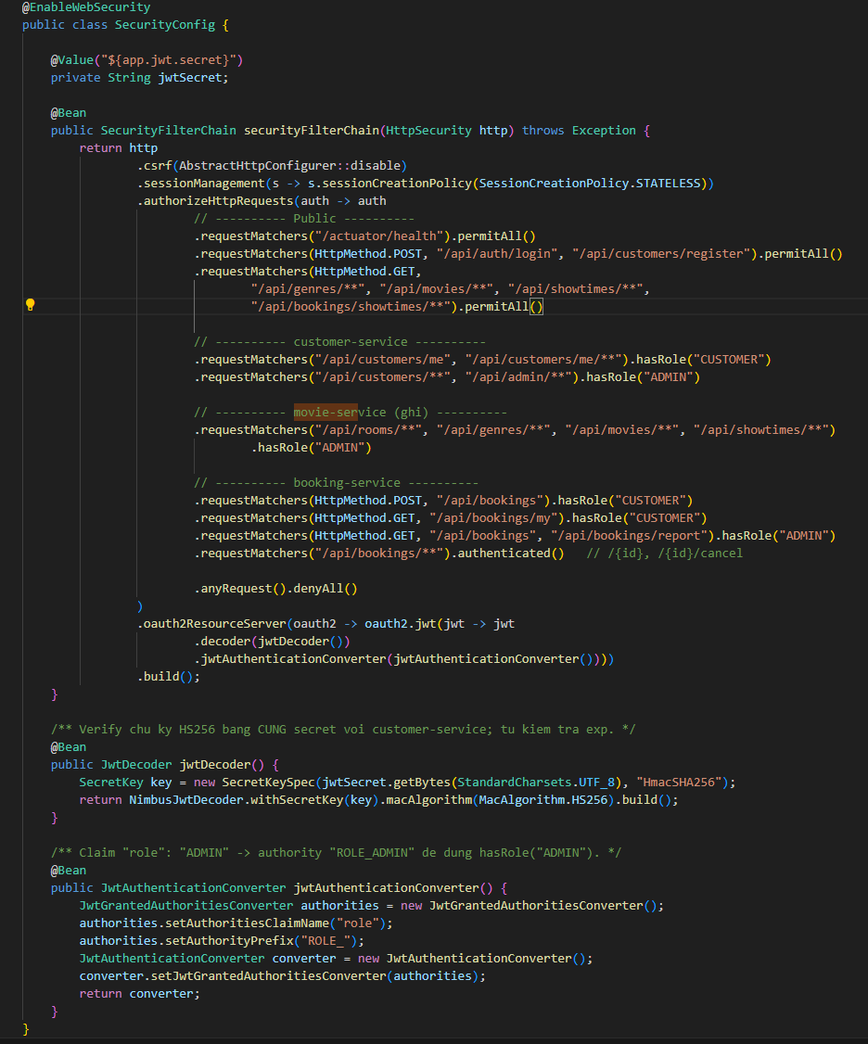

Bước 5.6 – Chạy gateway
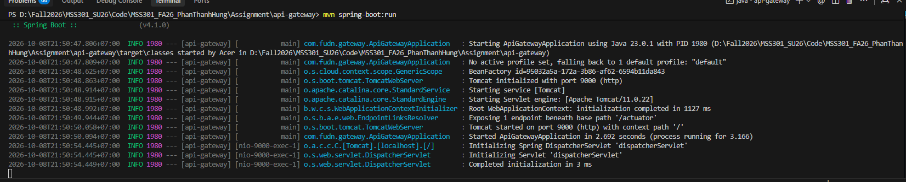

Chạy toàn hệ thống

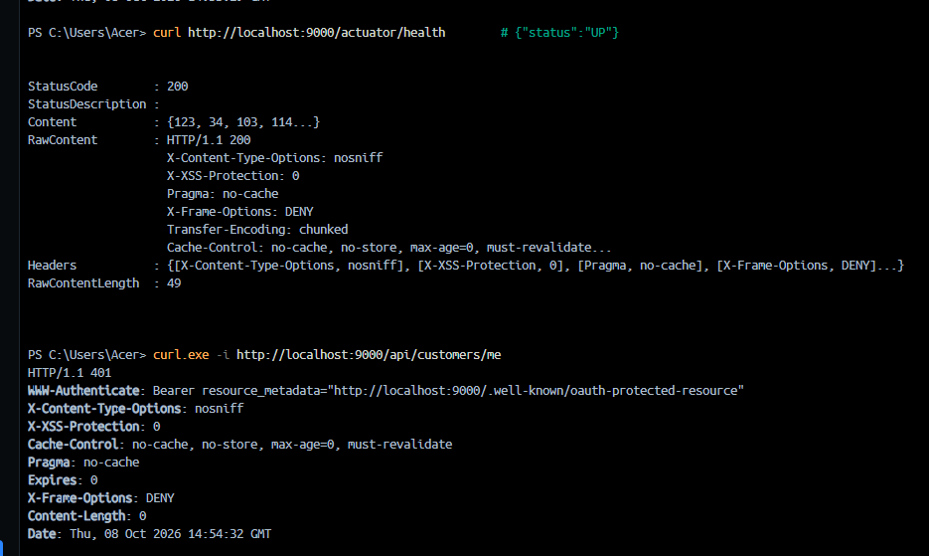
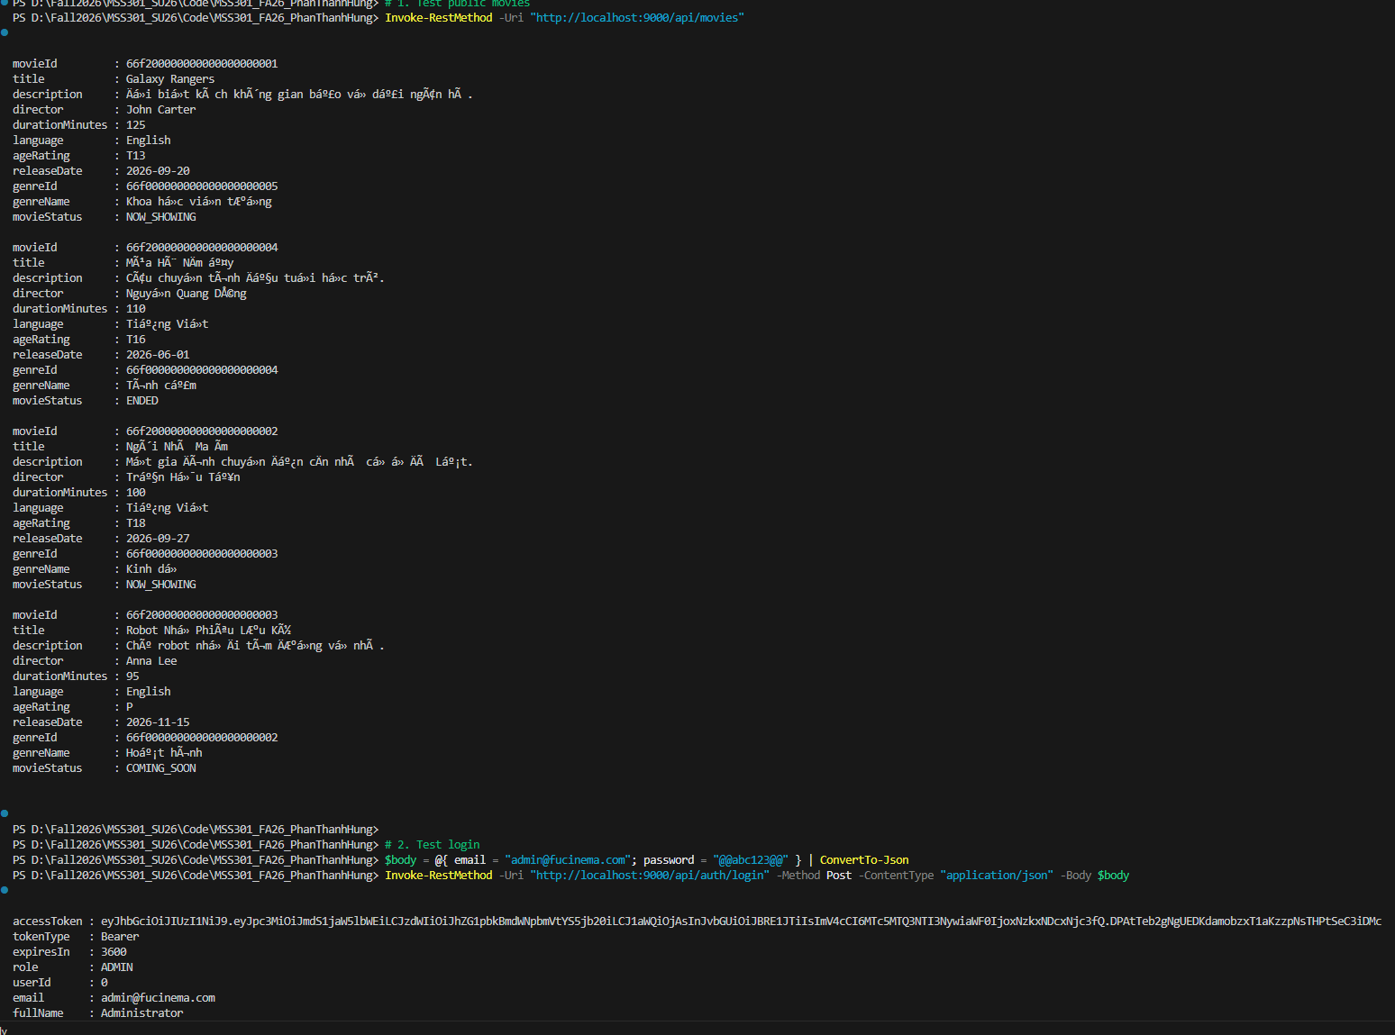

Kiểm thử API bằng Postman (F11)

(TODO 11.1) – Tạo Environment
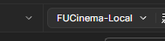

(TODO 11.2) – Tạo Collection & cách cấu hình request
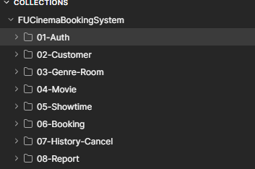

Folder 01-Auth (F1)
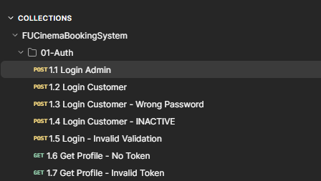
      - – Login Admin
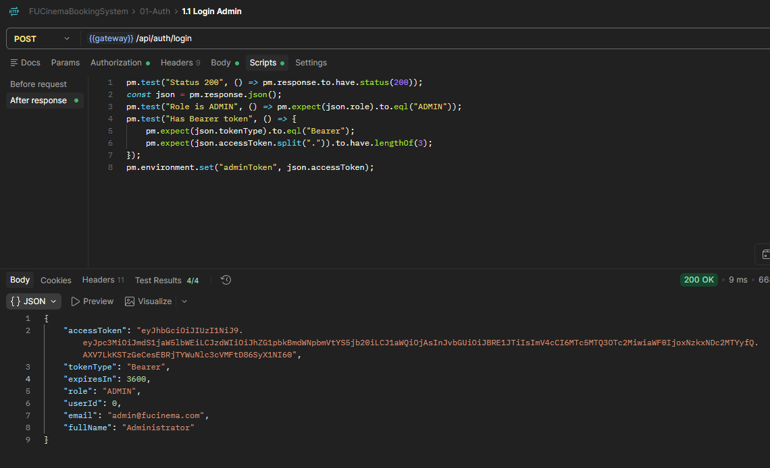
      - – Login Customer
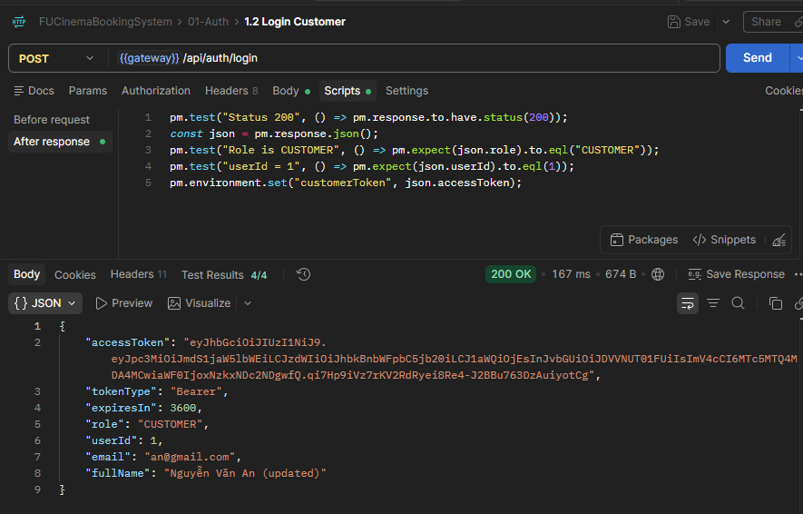
      - – Login Customer – Wrong Password
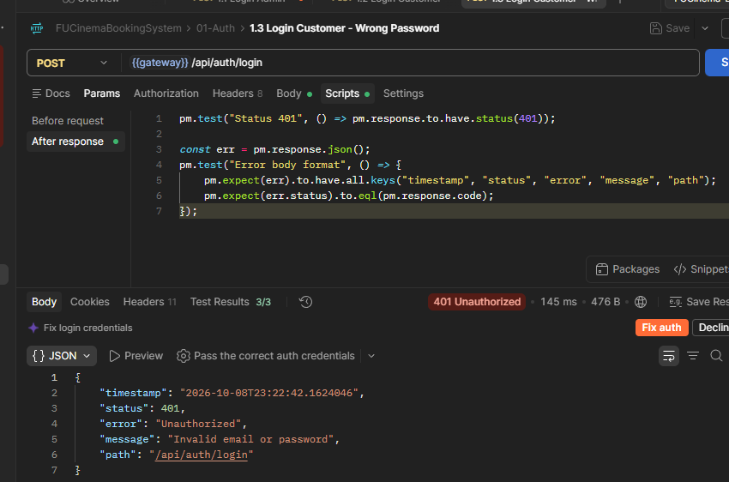
      - – Login Customer INACTIVE
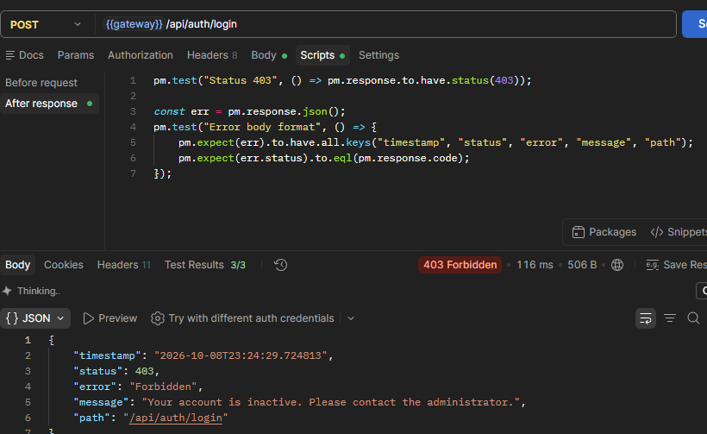
      - Login – Invalid Validation
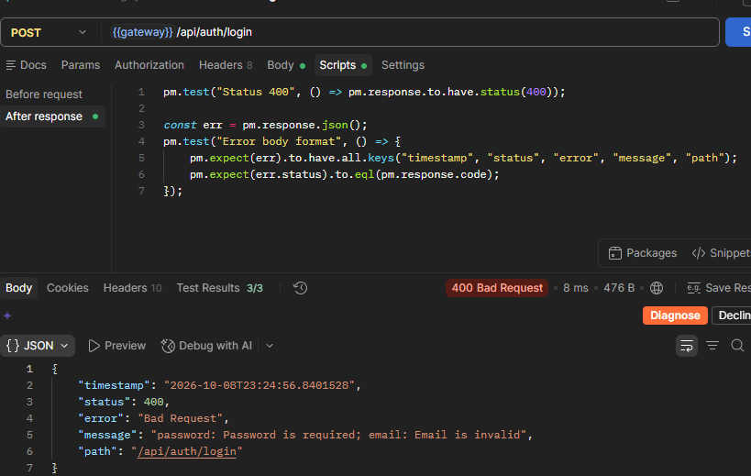
      - Get Profile – No Token
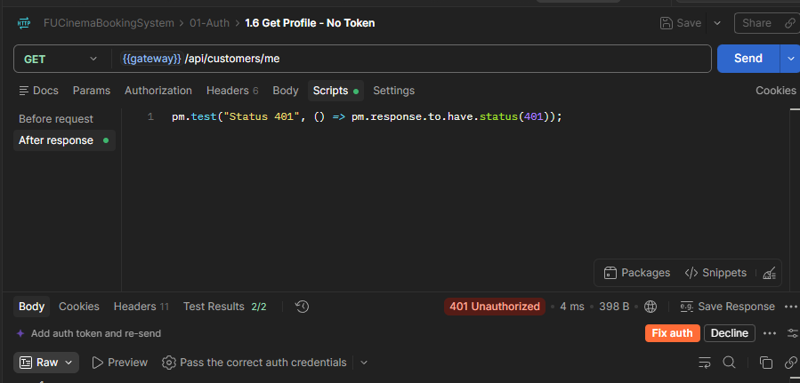
      - Get Profile – Invalid Token
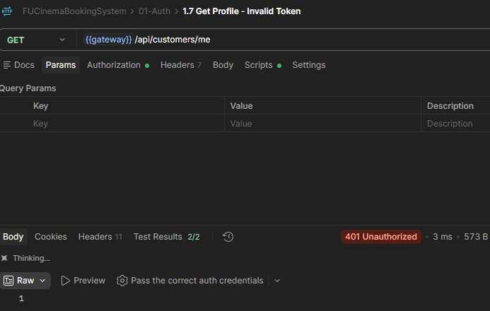

Folder 02-Customer (F2, F3)
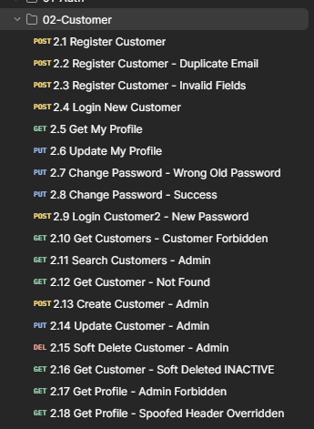

      - Register Customer
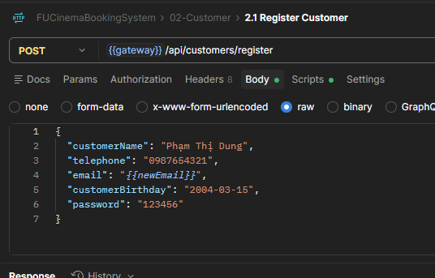
      - Register Customer – Duplicate Email
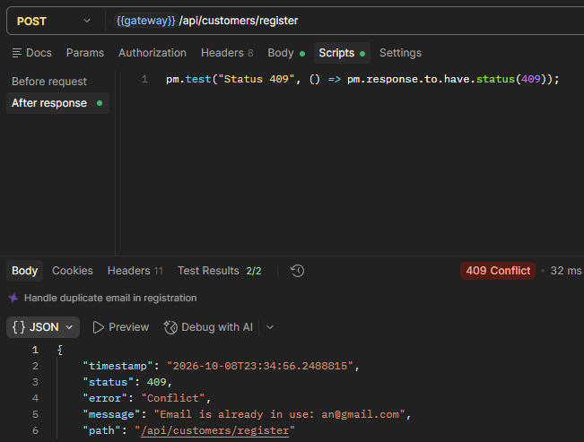
      - Register Customer – Invalid Fields
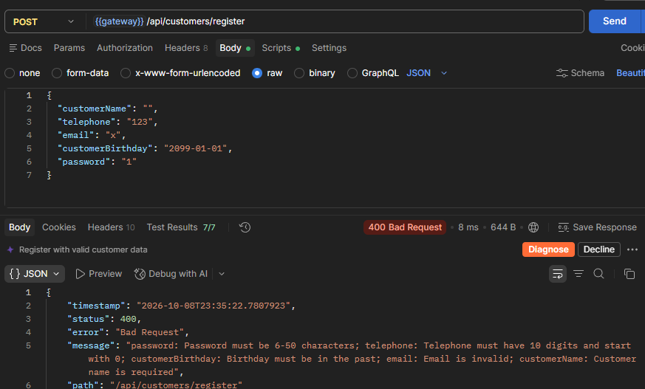
      - Login New Customer
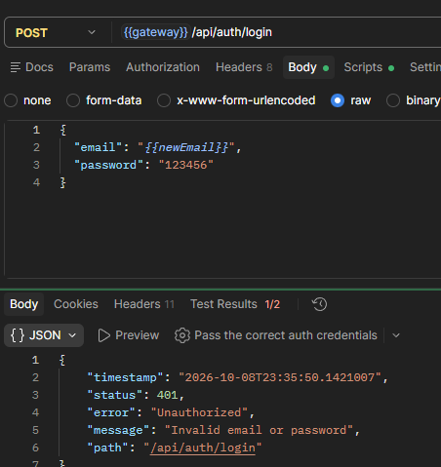
      - Get My Profile
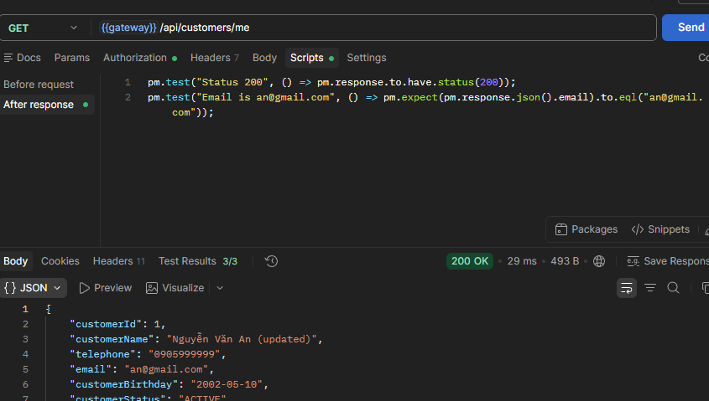

      - Update My Profile
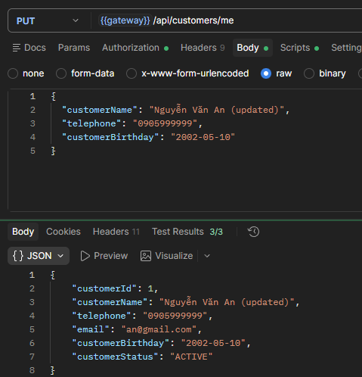
      - Change Password – Wrong Old Password
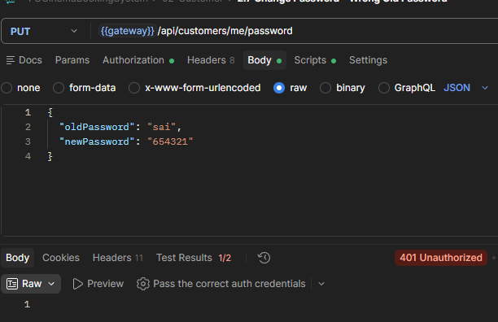
      - Change Password – Success
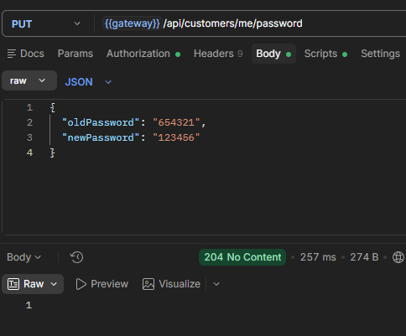
      - Login Customer2 – New Password

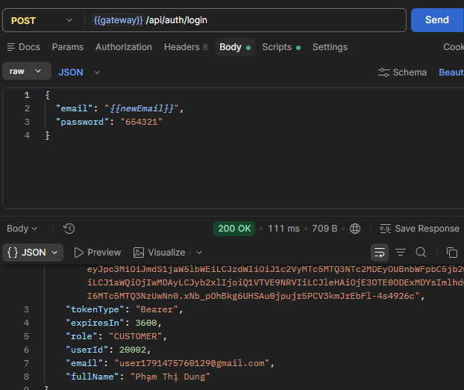

      - Get Customers – Customer Forbidden
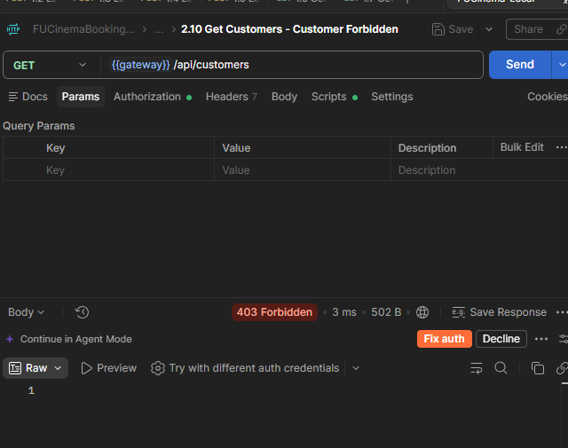
      - Search Customers – Admin
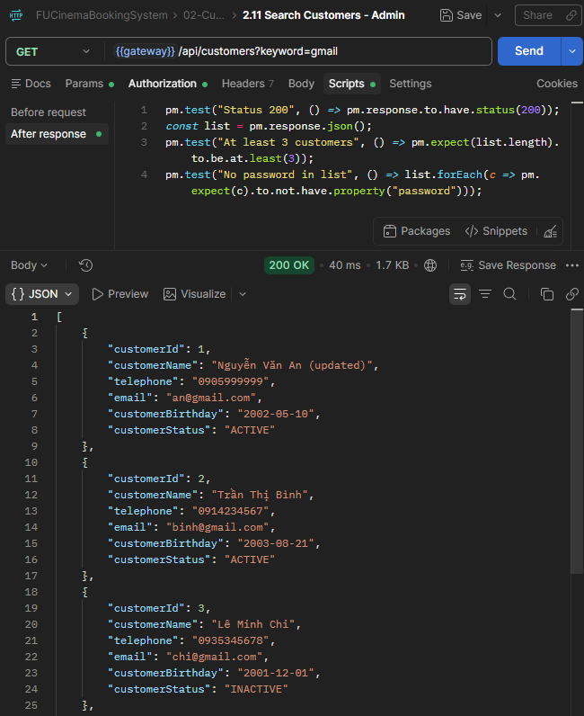
      - Get Customer – Not found
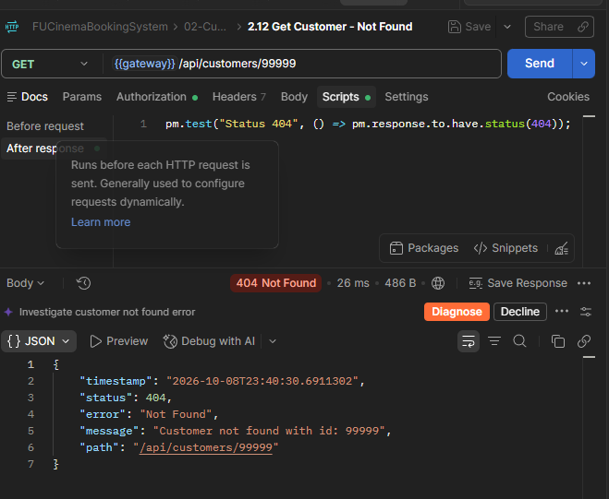
      - Create Customer – Admin
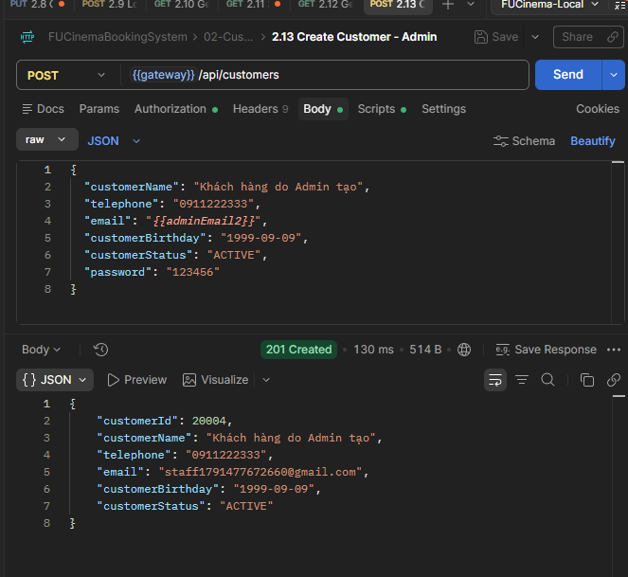

      - Update Customer – Admin
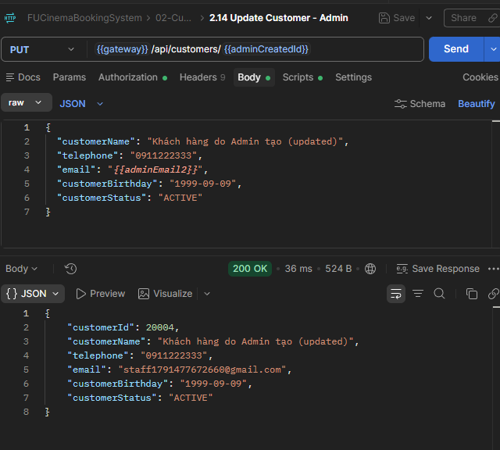
      - Soft Delete Customer – Admin
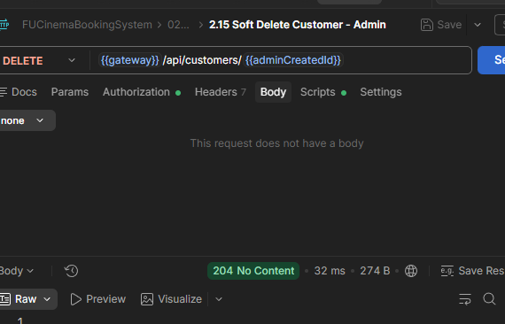

      - Get Customer – Soft Deleted INACTIVE
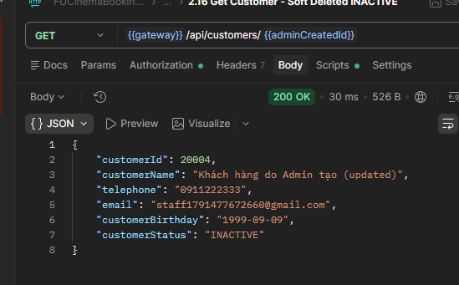
      - Get Profile – Admin Forbidden
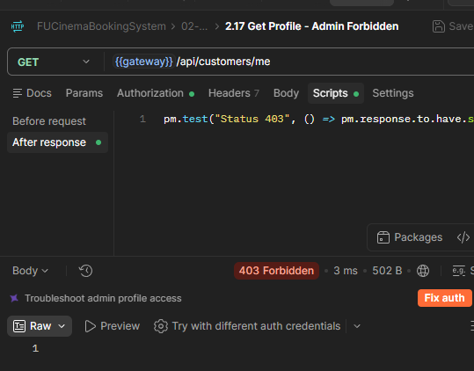
      - Get Profile – Spoofed Header Overridden
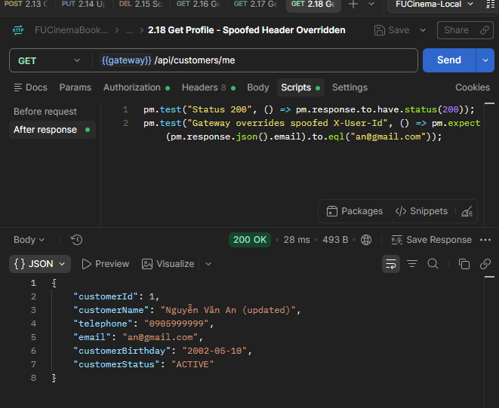

Folder 03-Genre-Room (F4)
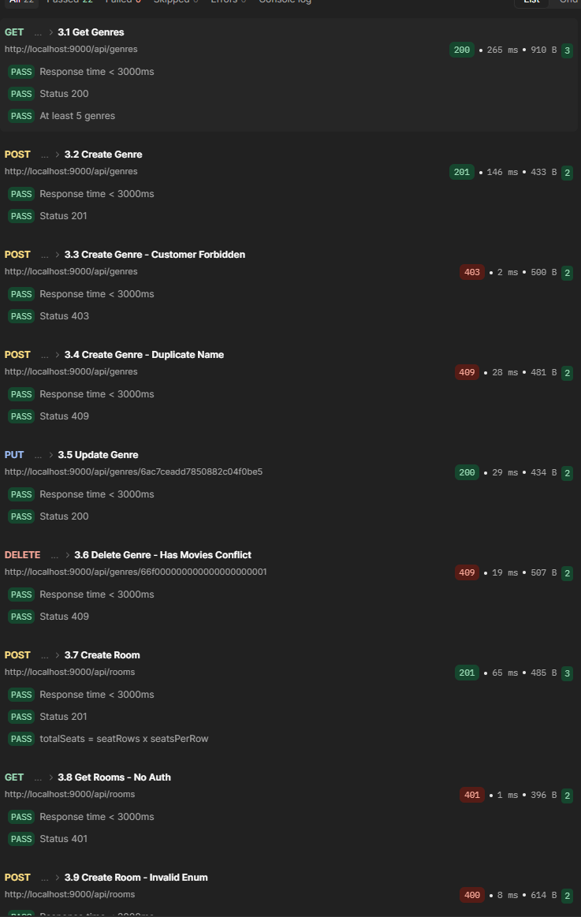
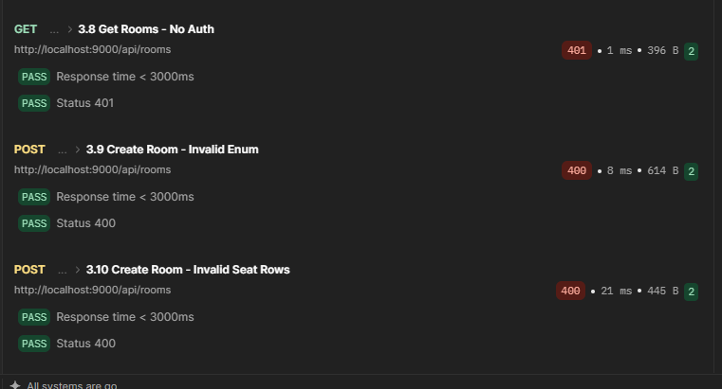

Folder 04-Movie (F5)
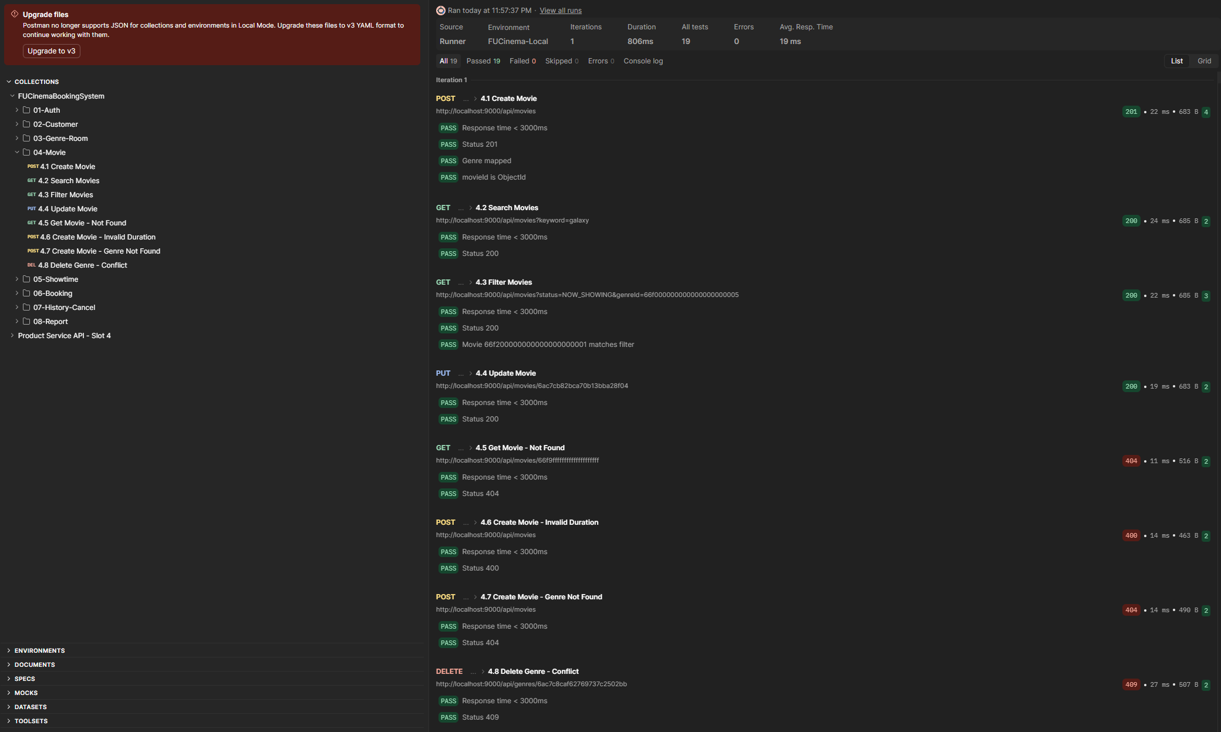

Folder 0-5-Showtime (F6)
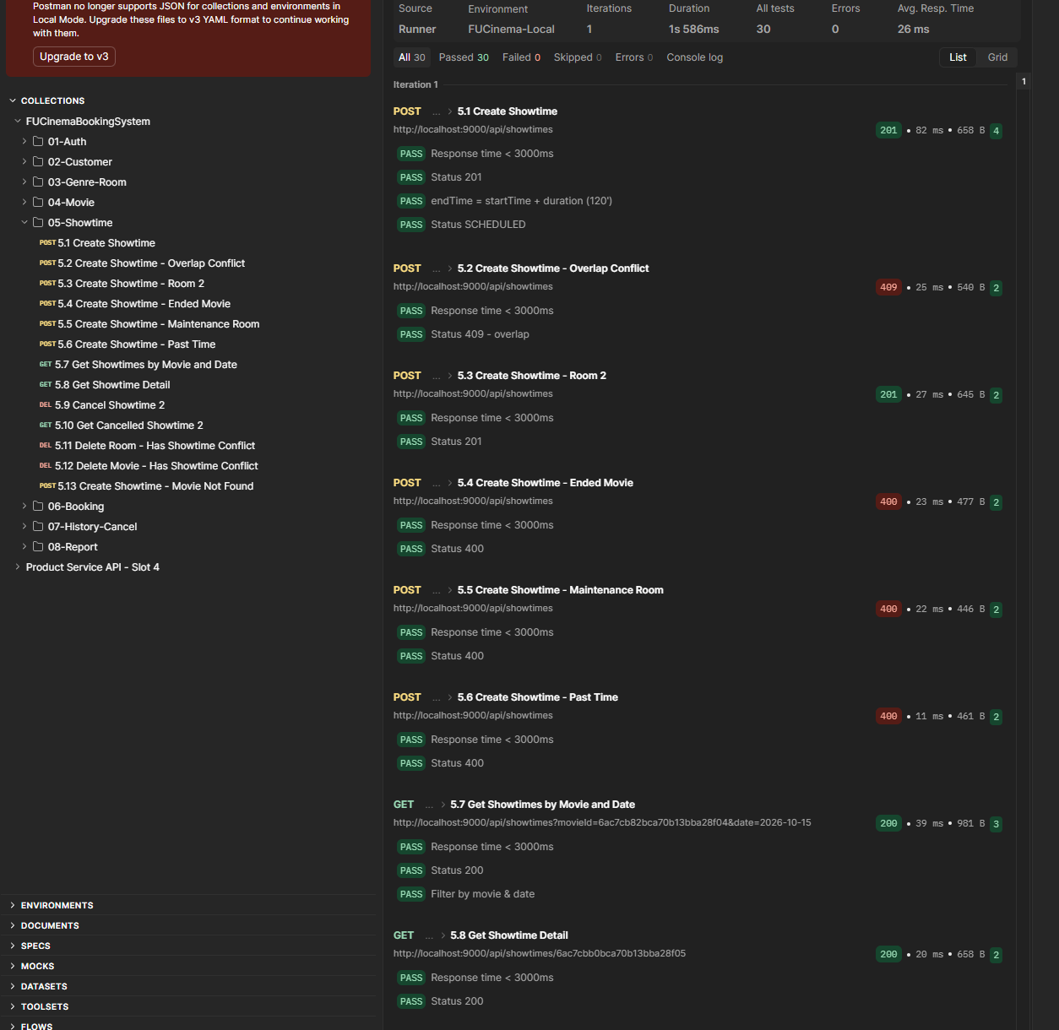

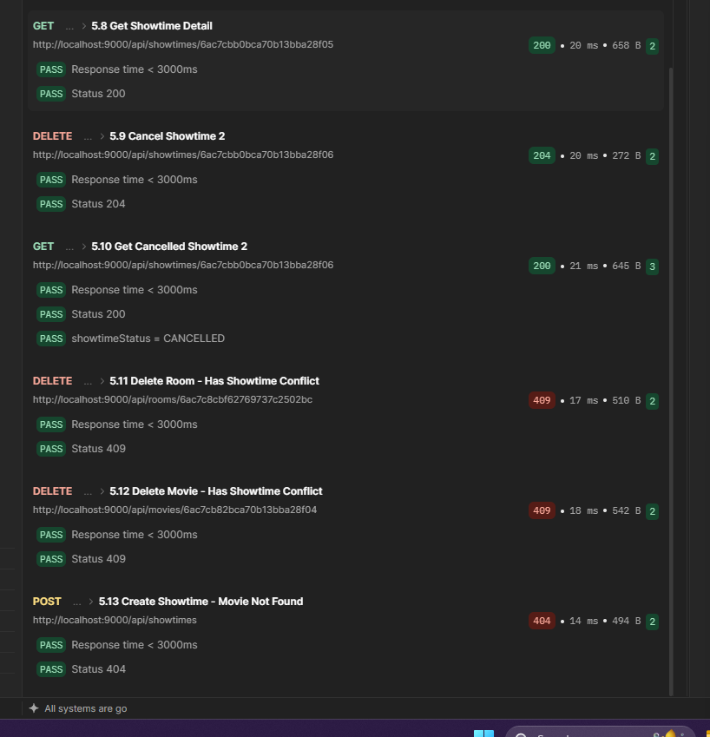

Folder-06-Booking
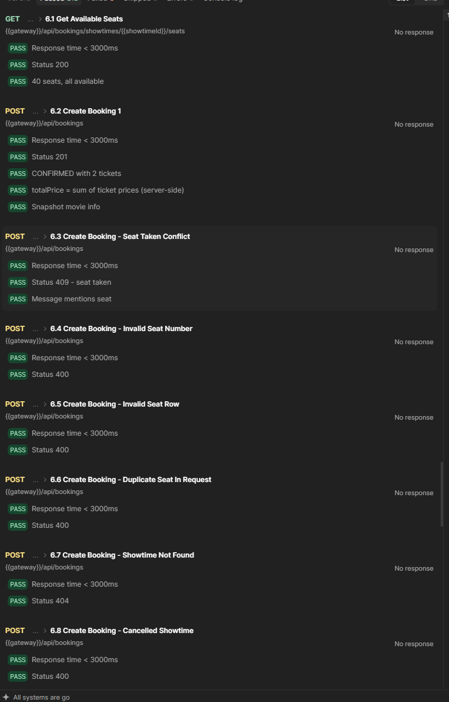
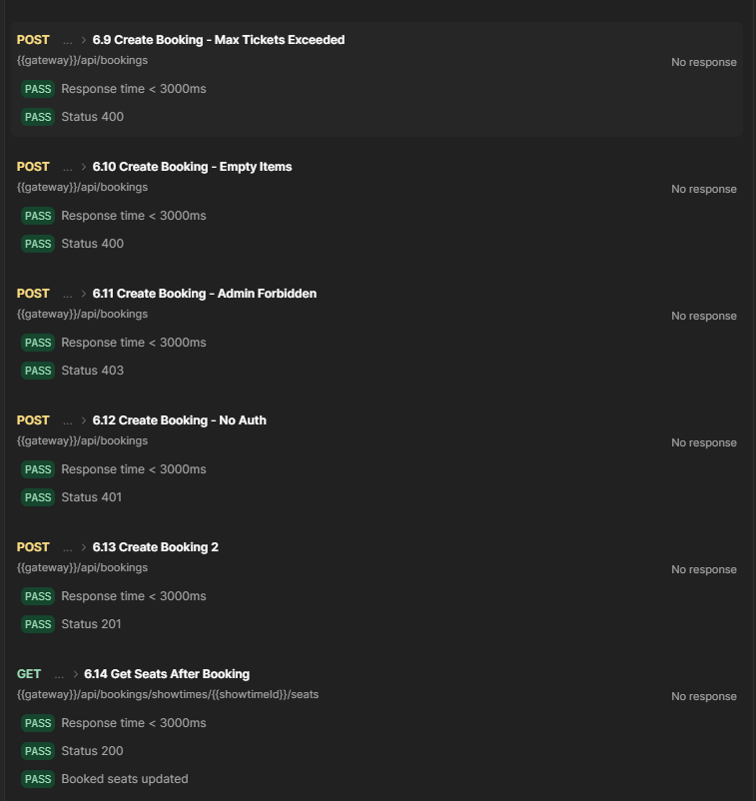

Folder-07-History-Cancel
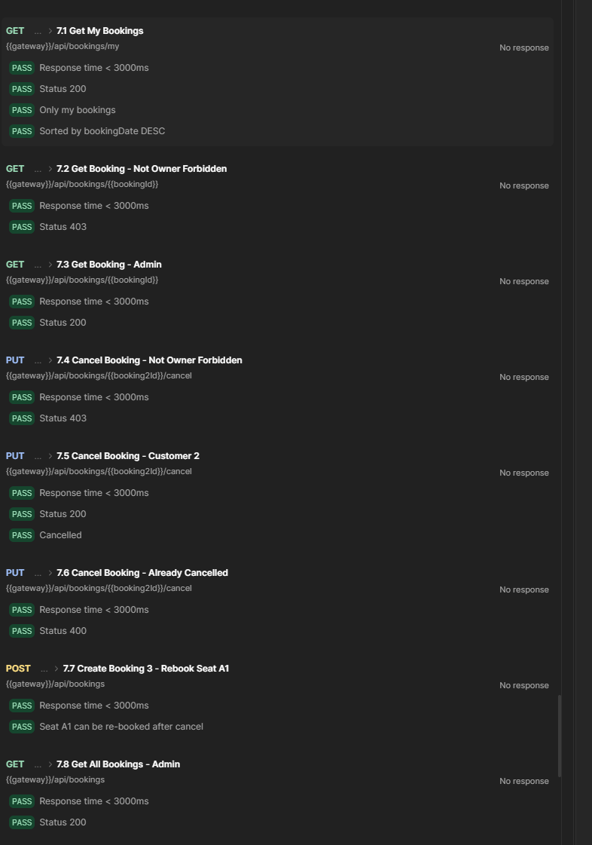
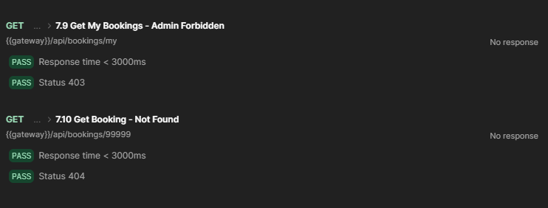

Folder-08-Report
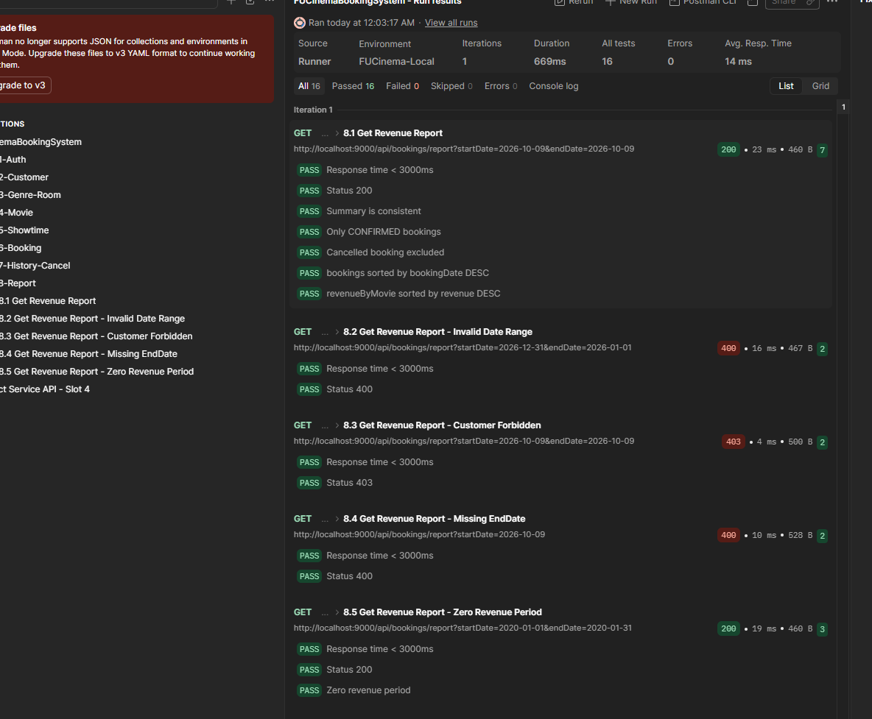

7.2b. - Kiểm tra trực tiếp trong 3 database (sau khi chạy Collection)

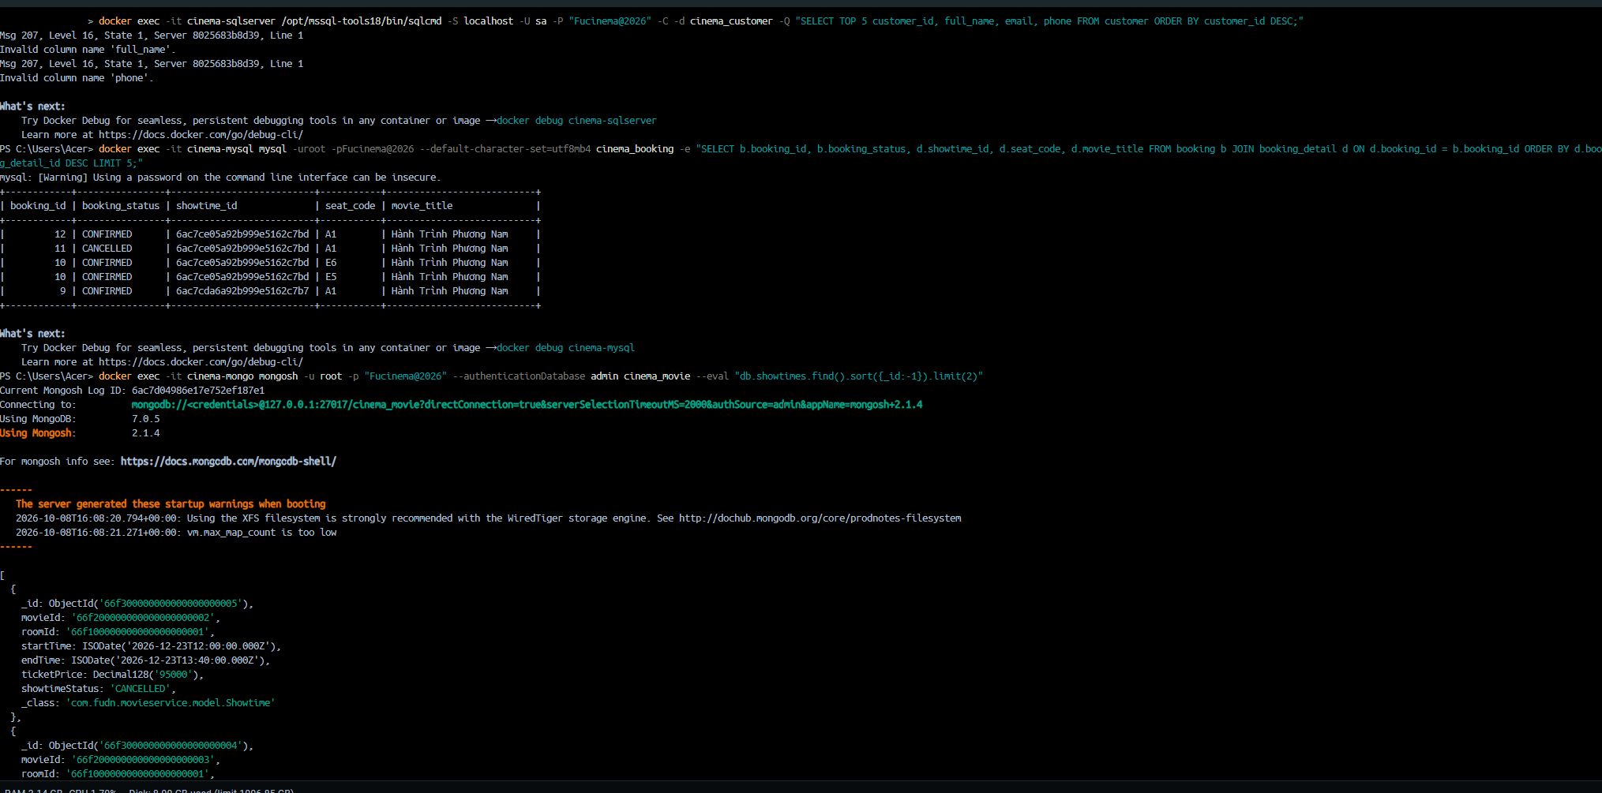
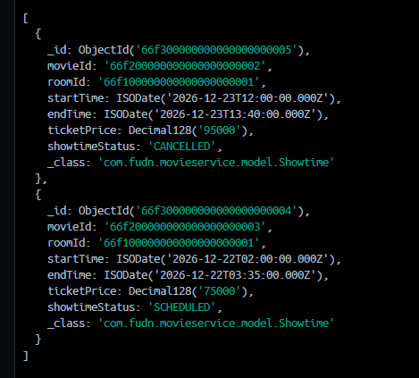

(TODO 11.3) – Chạy Collection Runner & nộp bài
